 **Project On**

**Agriculture Management System**



**LJ INSTITUTE OF COMPUTER APPLICATIONS**

## &

**MASTER OF COMPUTER APPLICATIONS**

**Group No: 108 Semester:** **4**

**Division: A**

**Project Developed By:-**

**A06-Chudesara Amit (23004401110043)**

**A18-Khavadiya Ankit (23004401110119)**

**A46-Saiyed Simun (23004401110263)**

**Guided By:-**

**Dr. Bhavin Shah**

**L J University**

**School of Computer Applications**

**Dept. of Master of Computer Applications**

Near Sarkhej Cross Roads,

Ahmedabad – 382210, Gujarat, India.  
Website: [www.ljku.edu.in](http://www.ljku.edu.in)



CERTIFICATE

**DIV: A ROLL NO: 06 ENROLLMENT NO: 23004401110043**

This is to certify that **Mr**. **Amit Chudesara** studying in Master of Computer Applications (MCA), Semester IV, has satisfactorily completed **his Software**

**Project Titled** Agriculture Management System

**Date of Submission:**

**Dr. Bhavin Shah**

**Internal Guide**

**Dr. Bhavin Shah Prof. Alok Manke**

**HOD Director**

**L J University**

**School of Computer Applications**

**Dept. of Master of Computer Applications**

Near Sarkhej Cross Roads,

Ahmedabad – 382210, Gujarat, India.  
Website: [www.ljku.edu.in](http://www.ljku.edu.in)



CERTIFICATE

**DIV: A ROLL NO: 18 ENROLLMENT NO: 23004401110119**

This is to certify that **Mr.** **Khavadiya Ankit** studying in Master of Computer Applications (MCA), Semester IV, has satisfactorily completed **his Software**

**Project Titled** Agriculture Management System

**Date of Submission:**

**Dr. Bhavin shah**

**Internal Guide**

**Dr. Bhavin Shah Prof. Alok Manke**

**HOD Director**

**L J University**

**School of Computer Applications**

**Dept. of Master of Computer Applications**

Near Sarkhej Cross Roads,

Ahmedabad – 382210, Gujarat, India.  
Website: [www.ljku.edu.in](http://www.ljku.edu.in)



CERTIFICATE

**DIV: A ROLL NO: 46 ENROLLMENT NO: 23004401110263**

This is to certify that **Mr.** **Saiyed Simun** studying in Master of Computer

Applications (MCA), Semester IV, has satisfactorily completed **her Software**

**Project Titled** Agriculture Management System

**Date of Submission:**

**Dr. Bhavin Shah**

**Internal Guide**

**Dr. Bhavin Shah Prof. Alok Manke**

**HOD Director**

* + - * + **Acknowledgement**

The success and final outcome of this project required a lot of guidance and assistance from many people and I am extremely privileged to have got this all along the completion of my project. All that I have done is only due to such supervision and assistance and I would not forget to thank them.

I respect and thank **Professor Dr. Bhavin Shah**, for providing me an opportunity to do the project work in **L. J. Institute of Computer application** and giving us all support and guidance, which made me complete the project duly.

I owe my deep gratitude to our project guide **Professor Dr. Bhavin Shah** who took keen interest on our project work and guided us all along, till the completion of our project work by providing all the necessary information developing a good system.

Last but not the least we are also thankful to our friends, project partners, colleagues and parents for support and understanding the provided us during the project work. We are also very much thankful to all who directly or in directly helped us.

**A06-Chudesara Amit (23004401110043)**

**A18-Khavadiya Ankit (23004401110119)**

**A46-Saiyed Simun (23004401110263)**

* **Index**

|  |  |  |
| --- | --- | --- |
| **Sr. No** | **Details** | **Page No.** |
| 1 | **Introduction** | 1 |
|  | 1.1. Existing System | 2 |
|  | 1.2. Need of the new system | 10 |
|  | 1.3. Objective of the New System | 12 |
|  | 1.4. Problem Definition | 12 |
|  | 1.5. Core Components | 13 |
|  | 1.6. Project Profile | 17 |
|  | 1.7. Assumptions and Constraints | 18 |
|  | 1.8. Advantages and Limitations of the Proposed System | 20 |
| 2 | **Requirement Determination and Analysis** | 22 |
|  | 2.1. Requirement Determination | 22 |
|  | 2.2. Requirement Specification | 27 |
|  | 2.3. Targeted User | 37 |
| 3 | **System Design** | 39 |
|  | 3.1. Use Case Diagram | 39 |
|  | 3.2. Data Dictionary | 40 |
| 4 | **Development** | 50 |
|  | 4.1. Coding Standards | 50 |
|  | 4.2. Screen Shots | 56 |
| 5 | **Agile Document** | 71 |
|  | 5.1. Agile Project Charter | 72 |
|  | 5.2. Agile Roadmap / Schedule | 73 |
|  | 5.3. Agile Project Plan | 75 |
|  | 5.4. Agile User Story (Minimum 3 Tasks) | 77 |
|  | 5.5. Agile Release Plan | 79 |
|  | 5.6. Agile Sprint Backlog | 83 |
|  | 5.7. Agile Test Plan | 86 |
|  | 5.8. Earned-value and burn charts | 88 |
| 6 | **Proposed Enhancement** | 89 |
|  | 6.1. Proposed Enhancement | 89 |
| 7 | **Conclusion** | 90 |
|  | 7.1. Conclusion | 90 |
| 8 | **Bibliography** | 91 |
|  | 8.1. Bibliography | 91 |

* **Introduction**

Agriculture plays a vital role in the economy, providing the backbone for food security and employment. However, the traditional methods of managing agricultural activities often result in inefficiencies, data loss, and operational delays. The **Agriculture Management System** is designed as a robust and user-friendly solution to digitize and streamline agricultural operations, ensuring better productivity, transparency, and decision-making.

The system, built using **PHP and MySQL**, is a web-based application aimed at providing a centralized platform for managing various agricultural processes. It offers features such as crop and livestock management, inventory tracking, irrigation scheduling, weather updates, and financial record keeping. By integrating these features, the system enables farmers and agricultural businesses to reduce manual effort, eliminate paperwork, and improve overall operational efficiency.

The use of **PHP** ensures that the system is lightweight, fast, and highly scalable, while **MySQL** provides a reliable and secure database solution for managing large volumes of agricultural data. The platform supports multiple user roles, such as farmers, managers, and administrators, to cater to different levels of access and functionality, ensuring data privacy and role-specific control.

This project is a step toward embracing modern technology to solve real-world agricultural challenges. By implementing this system, farmers can monitor resources, predict outcomes, and make informed decisions, ultimately contributing to sustainable farming practices and enhanced productivity.

**1.1. Existing System:**

In the current scenario, most agricultural activities are managed using traditional, manual methods. Farmers and agricultural businesses rely heavily on paper-based records, which are prone to damage, loss, and human error. Operations such as crop management, inventory tracking, irrigation scheduling, and financial record-keeping often lack centralization and proper documentation. This leads to inefficiencies, mismanagement of resources, and challenges in monitoring overall productivity.

Additionally, the absence of a digital system makes it difficult to integrate real-time weather updates, market prices, and crop yield predictions into decision-making. Farmers often face challenges in accessing data or making informed decisions based on trends, as the existing systems do not support automated analysis or reporting. Communication between different stakeholders, such as suppliers, distributors, and labourers, is fragmented, leading to delays and reduced operational efficiency.

Another significant drawback of the existing system is its inability to provide secure data storage. Important records related to crop cycles, expenses, and sales are often scattered, making it harder to retrieve and analyse historical data. The lack of integration with modern tools and technologies also makes the existing system ill-suited to adapt to the growing needs of precision farming and sustainability.

The limitations of the current system highlight the need for a robust, centralized, and automated platform to address these inefficiencies. The proposed **Agriculture Management System** aims to fill this gap by digitizing and streamlining agricultural processes, ensuring better resource utilization, and enhancing productivity for farmers and businesses.

Moreover, the inability to provide real-time collaboration among various stakeholders adds another layer of inefficiency. For instance, delays in communication between farmers and suppliers can result in late deliveries of essential inputs, while poor coordination with distributors can lead to missed market opportunities. These gaps in communication and collaboration hinder the overall growth and profitability of agricultural businesses.

Given these challenges, the existing system’s shortcomings highlight the pressing need for modernization. A robust, centralized, and automated platform can address these inefficiencies by digitizing and streamlining agricultural processes. Such a system would integrate tools for real-time data analysis, secure data storage, and seamless communication between stakeholders. It would also enable better resource utilization, improved decision-making, and enhanced productivity for farmers and agricultural businesses.

The proposed Agriculture Management System aims to fill this gap by offering a comprehensive solution that combines modern technology with user-friendly features. By digitizing operations, the system will not only address the inefficiencies of traditional methods but also pave the way for sustainable and precision-driven farming practices. This will empower farmers and agricultural businesses to achieve greater productivity and profitability while meeting the demands of a rapidly evolving agricultural landscape.

**The Organic Farming Research Foundation (OFRF):**

* The Organic Farming Research Foundation (OFRF) was established in 1990 as a non-profit organization focused on advancing organic agriculture through research and education.
* OFRF fosters organic farming systems, supports farmer-led research, and promotes policies that enhance organic production.
* It addresses challenges in organic farming such as pest management, soil health, and crop diversity through research initiatives.
* The foundation provides grants to researchers and farmers to encourage innovative practices and solutions in organic farming.
* OFRF collaborates with universities, agricultural organizations, and government agencies to disseminate research findings and promote best practices.
* The organization offers educational resources, workshops, and webinars to keep farmers updated on the latest developments in organic agriculture.
* OFRF emphasizes community engagement, ensuring research knowledge is accessible to all stakeholders in the organic farming sector.
* It regularly publishes reports and newsletters highlighting research findings, success stories, and practical applications of organic farming techniques.
* The foundation advocates for policies supporting organic farmers at local, state, and national levels, influencing legislation to benefit the organic sector.
* OFRF promotes sustainable practices such as cover cropping, crop rotation, and integrated pest management to maintain soil fertility and reduce reliance on synthetic inputs.
* Outreach programs connect farmers with resources and tools necessary for successful organic farming.
* The foundation increases public awareness about the benefits of organic agriculture and advocates for consumer education on supporting organic products.
* OFRF partners with non-profits and educational institutions to broaden the impact of research and outreach efforts.
* The organization actively participates in conferences and symposiums to facilitate knowledge exchange among farmers, researchers, and industry experts.
* It fosters a collaborative environment to encourage continuous learning and adaptation in organic farming methods.
* OFRF collects and shares data on crop yields, pest occurrences, and soil health to help farmers make informed decisions.
* It involves farmers in participatory research methods, ensuring findings are relevant and applicable to real-world farming situations.
* The foundation advocates for increased funding and policies supporting organic research and upholding organic standards.
* OFRF engages in international collaboration to address global challenges related to food security and environmental sustainability.
* It supports underrepresented groups in agriculture, including minority and women farmers, by providing resources and opportunities for success.
* Consumer engagement is a priority, with outreach campaigns educating the public on the health, environmental, and economic benefits of organic farming.
* The foundation facilitates peer-to-peer learning and support among farmers to strengthen the organic farming community.
* OFRF develops tools, guides, and online resources to help farmers implement best practices effectively.
* It monitors and evaluates the impact of its initiatives to ensure responsiveness to the needs of the organic farming community.
* The foundation’s research explores the role of organic practices in mitigating climate change and enhancing resilience.
* OFRF supports the development of organic certification programs to ensure transparency and integrity in the organic market.
* It promotes the adoption of innovative technologies and precision agriculture techniques to optimize resource use and improve crop management.
* Partnerships with businesses and industry stakeholders strengthen sustainable supply chains that support organic farmers.
* Youth engagement programs inspire the next generation of farmers and consumers to embrace organic practices.
* OFRF disseminates research findings through academic journals, conferences, and community events to reach a broad audience.
* The foundation prioritizes transparency and accessibility, fostering trust and encouraging the adoption of organic practices.
* Through its comprehensive efforts, OFRF ensures organic agriculture remains a thriving and sustainable sector for future generations.

**Access Agriculture:**

* Access Agriculture is a non-profit organization promoting sustainable agricultural practices through training videos.
* The website provides free access to a vast library of high-quality training materials focused on ecological farming and agro ecology.
* Videos are available in multiple languages, ensuring accessibility for farmers worldwide.
* Training videos cover various topics, including crop production, livestock management, pest control, and soil health.
* Real-life examples and demonstrations make the content engaging and easy to understand.
* Visual storytelling effectively communicates complex agricultural concepts in an accessible manner.
* The platform emphasizes knowledge sharing and collaboration among farmers to foster a community of learning.
* Farmers are encouraged to share experiences and insights, creating a participatory environment.
* Access Agriculture features blogs, news, and updates on sustainable farming trends and success stories.
* The platform promotes agro ecology, reducing dependency on chemical inputs and fostering biodiversity.
* A user-friendly interface allows easy navigation through videos and resources.
* Mobile-friendly design ensures accessibility for farmers in regions with limited internet access.
* Partnerships with agricultural organizations, NGOs, and research institutions expand the reach and quality of training.
* Content is regularly updated to incorporate the latest agricultural research and innovations.
* The organization actively collects user feedback to tailor training materials to farmers' needs.
* Training videos include strategies for climate-smart agriculture and adapting to climate change.
* Youth engagement programs target young farmers, promoting innovation and addressing the aging farming population.
* Inclusivity efforts focus on empowering marginalized groups, including women and youth in agriculture.
* Outreach programs include workshops, seminars, and community events to share knowledge and best practices.
* The platform showcases success stories to inspire farmers to adopt sustainable practices.
* Access Agriculture participates in international forums, contributing to global agricultural policy discussions.
* The platform bridges the gap between researchers and practitioners, fostering collaboration and knowledge exchange.
* Holistic training includes soft skills like leadership, communication, and problem-solving.
* Advocacy efforts influence agricultural policies to support sustainable practices and food security.
* Monitoring and evaluation of training programs ensure effectiveness and continual improvement.
* The platform addresses the mental health and well-being of farmers by promoting stress-reducing practices.
* Localized content addresses specific regional agricultural challenges, building trust among farmers.
* Access Agriculture tailors its resources to the unique needs of Africa, Asia, and Latin America.
* Resources for trainers and facilitators amplify the reach and impact of training programs.
* Collaborations with local organizations ensure culturally appropriate and effective training.
* Technology integration, such as mobile accessibility, enhances agricultural education.
* Success stories highlight the benefits of sustainable practices like improved yields and resilience.
* The organization fosters a culture of collaboration, inclusivity, and innovation in sustainable agriculture.
* By empowering farmers globally, Access Agriculture contributes to building a more sustainable and equitable food system.

**Agri Stack:**

* Agri Stack is an innovative digital initiative launched by the Indian government aimed at transforming the agricultural landscape of the country.
* The platform serves as a comprehensive digital infrastructure connecting stakeholders in agriculture, including farmers, agribusinesses, and government agencies.
* The primary objective of Agri Stack is to enhance agricultural efficiency and productivity using technology and data-driven solutions.
* Agri Stack provides farmers access to essential information, tools, and support to make informed decisions about their farming practices.
* At the core of Agri Stack is a unified farmer registry, which collects and manages data related to farmers and their agricultural activities.
* The centralized database ensures the government can tailor its policies and programs to meet the needs of the agricultural community more effectively.
* The platform offers personalized recommendations for farmers, considering factors like crops, climate, and market trends.
* Agri Stack provides a range of digital services to improve farmers' access to critical information, resources, and best practices (e.g., crop management, pest control, soil health).
* The platform facilitates access to financial services, such as loans and insurance, to help farmers invest in their operations and mitigate risks.
* Agri Stack aims to empower farmers by streamlining these processes and improving overall agricultural productivity.
* The platform promotes collaboration among government agencies, research institutions, and private sector players to drive innovation.
* Agri Stack integrates services to promote transparency and accountability, which are essential for building trust among stakeholders.
* By digitizing agricultural processes, Agri Stack addresses challenges like limited access to information, inadequate financial support, and lack of market linkages.
* The initiative envisions a more resilient and sustainable agricultural sector capable of adapting to changing conditions and increasing food demand.
* Data privacy and security are prioritized to protect farmers' personal information while using data for effective policymaking and service delivery.
* Agri Stack enhances financial inclusion by making it easier for farmers to access credit and insurance products through better data analysis.
* The platform improves market access for farmers by offering real-time information on market prices and demand, helping farmers make better sales decisions.
* By connecting farmers directly with markets, Agri Stack reduces the role of intermediaries, ensuring fair pricing and better income for farmers.
* Sustainable agricultural practices are promoted by providing farmers with knowledge on eco-friendly farming techniques to reduce environmental impact.
* The platform will evolve by integrating advanced technologies such as artificial intelligence and machine learning, providing predictive insights to improve farming decisions.
* Training modules and resources will help farmers improve their skills and knowledge, encouraging the adoption of new technologies and modern practices.
* Agri Stack supports the development of agricultural cooperatives and farmer groups to improve resource pooling, knowledge-sharing, and access to larger markets.
* These cooperatives and groups help increase bargaining power, improving the economic viability of farming operations, especially for smallholders.
* The initiative also focuses on building partnerships with private sector players, NGOs, and international organizations, bringing additional resources and expertise to the agricultural sector.
* Agri Stack aims to create a robust and resilient agricultural ecosystem, addressing both current and future challenges of the agricultural community.
* The platform's success relies on continuous feedback from farmers and stakeholders to ensure it remains relevant and effective.
* Iterative development will help refine services to better meet the evolving needs of farmers and the agricultural sector.
* Agri Stack encourages stakeholder engagement, ensuring that the voices of farmers are considered during the ongoing enhancement of the platform.
* The initiative is committed to fostering a participatory environment, where farmers are encouraged to share experiences and insights, leading to a community of learning.
* By offering predictive insights through data, Agri Stack creates a more proactive approach to farming that allows farmers to anticipate market trends, weather conditions, and pest outbreaks.
* The educational component will empower farmers with practical training and resources, improving their overall capabilities in agriculture.
* Agri Stack fosters collaboration and knowledge exchange, encouraging a community-driven approach to agriculture.
* Partnerships with various stakeholders will contribute to building a sustainable and resilient agricultural sector in India.
* The initiative envisions a prosperous future for farmers, improving livelihoods, and ensuring food security for the nation.

**1.2. Need of the new system:**

• **Centralized Data Management**

* Traditional agricultural record-keeping involves physical documents, which can be prone to loss or damage. A centralized system ensures all data is securely stored and easily accessible.

• **Improved Resource Allocation**

* The new system helps track and manage resources such as seeds, fertilizers, and equipment, minimizing wastage and ensuring optimal utilization.

• **Enhanced Productivity**

* By digitizing key processes like crop scheduling, irrigation planning, and inventory management, the system streamlines operations and reduces manual workload.

• **Real-Time Monitoring**

* Farmers can monitor critical parameters like crop health, irrigation status, and weather conditions in real time, leading to timely interventions.

• **Automation of Repetitive Tasks**

* Tasks such as financial calculations, resource inventory updates, and generating reports are automated, saving time and reducing human error.

• **Accessibility and Convenience**

* Being a web-based system, it can be accessed from any device with an internet connection, making it convenient for farmers in remote areas.

• **Cost-Effective Operations**

* By improving efficiency and reducing errors, the system helps in cutting unnecessary costs and maximizing profits.

• **Scalable for Future Needs**

* Built with PHP and MySQL, the system can be easily expanded to incorporate additional features or support a growing user base.

• **Role-Based Access Control**

* Different user roles (e.g., farmers, vendor, and administrators) ensure secure and customized access to system functionalities.

• **Sustainability and Environmental Benefits**

* The system encourages sustainable farming practices by providing insights into optimal resource usage and reducing wastage.

**1.3. Objective of new system:**

* **Centralized Data Management**: Provide a unified platform to manage all agricultural data, including crops, livestock, inventory, and finances.
* **Automation of Processes**: Automate routine tasks such as irrigation scheduling, inventory tracking, and financial record maintenance to reduce manual effort.
* **Improved Decision-Making**: Offer real-time data insights and reports to help farmers and administrators make informed decisions.
* **Resource Optimization**: Efficiently allocate resources such as fertilizers, seeds, and water, minimizing wastage and maximizing productivity.
* **User Role Management**: Enable multi-user access with role-based permissions for farmers, administrators, and other stakeholders.
* **Scalability and Flexibility**: Design a system that can scale with the growing needs of the agricultural business and adapt to different types of farming activities.
* **Cost Efficiency**: Reduce operational costs by digitizing processes and eliminating the need for paper-based systems.
* **Real-Time Monitoring**: Provide real-time updates on weather conditions, crop health, and resource availability to improve planning.
* **Secure Data Storage**: Use MySQL to securely store and manage agricultural data, ensuring data integrity and privacy.
* **Ease of Use**: Develop an intuitive and user-friendly interface to make the system accessible even to users with minimal technical knowledge.
* **Sustainable Farming Practices**: Promote environmentally friendly practices by optimizing resource use and providing tools to monitor sustainability metrics.
* **Integration Capability**: Allow integration with third-party tools, APIs, or systems for advanced functionalities like weather forecasting or market price updates.

**1.4. Problem Definition:**

This system aims to provide tools for monitoring weather, soil conditions, and inventory while optimizing decision-making and promoting sustainability. It ensures better productivity, profitability, and environmental stewardship in the agricultural sector.

**1.5. Core Components:**

**1. User Management**

* **Description**: The user management component allows different users to access the system based on their roles (Admin, Farmer, vendor, etc.).
* **Functionality**:
  + **Registration**: Users can create their accounts with a secure authentication system.
  + **Login/Logout**: Users can log in and out with unique credentials.
  + **Role-based Access Control**: Depending on the user role, different permissions and access levels are assigned (e.g., an admin can manage users, but a farmer can only manage crops).
  + **Profile Management**: Users can update personal information, change passwords, and manage preferences.

**2. Crop Management**

* **Description**: This component enables farmers to manage their crops, from planting to harvesting.
* **Functionality**:
  + **Crop Details**: Add, update, and delete crop details, such as type, variety, planting date, etc.
  + **Growth Monitoring**: Track crop progress with data entry on the various growth stages and conditions.
  + **Harvesting and Yield Tracking**: Record the yield and harvest details for analysis.
  + **Crop Rotation**: Schedule and monitor crop rotation to improve soil health and productivity.

**3. Inventory Management**

* **Description**: This component manages agricultural products, tools, and resources.
* **Functionality**:
  + **Product Tracking**: Keep track of inventory items like seeds, fertilizers, pesticides, and tools.
  + **Stock Level Monitoring**: Alert users when stock levels reach a threshold and need replenishment.
  + **Purchase/Usage Logs**: Maintain records of purchased and used inventory, helping users monitor expenses and resource usage.

**4**. **Irrigation Management**

* **Description**: This component allows the system to schedule and track irrigation needs for the crops.
* **Functionality**:
  + **Irrigation Scheduling**: Automatically schedule irrigation based on crop type, weather conditions, and soil moisture levels.
  + **Water Usage Tracking**: Monitor and record water usage to optimize irrigation and reduce waste.
  + **Alerts**: Notify farmers of irrigation needs or system malfunctions.

**5. Weather Forecasting and Alerts**

* **Description**: Integration with weather APIs provides real-time updates on weather conditions, helping farmers plan activities.
* **Functionality**:
  + **Weather Data**: Fetch real-time data for temperature, humidity, rainfall, etc.
  + **Weather Alerts**: Notify users about severe weather conditions like storms, frosts, or droughts.
  + **Forecasts for Crops**: Provide weather forecasts specific to crop types, advising farmers on optimal planting or harvesting times.

**6**. **Financial Management**

* **Description**: This component assists farmers and managers in tracking the financial aspects of agricultural operations.
* **Functionality**:
  + **Expense Tracking**: Record all expenses, including purchases of seeds, fertilizers, equipment, etc.
  + **Income Tracking**: Track revenue from sales of crops, livestock, or other products.
  + **Profit/Loss Analysis**: Generate reports showing profit or loss, helping with budgeting and decision-making.
  + **Tax and Legal Compliance**: Maintain records for compliance with agricultural regulations, tax filings, and government subsidies.

**7**. **Reporting and Analytics**

* **Description**: This component provides various analytical tools and reports to improve farm management decisions.
* **Functionality**:
  + **Crop Reports**: Generate detailed reports on crop performance, yield data, and harvesting patterns.
  + **Financial Reports**: Display graphs and tables summarizing income, expenses, and profitability.
  + **Custom Reports**: Create customized reports based on user inputs, offering insights into various aspects of farm management.

**8**. **Communication System**

* **Description**: Enables communication between different users and stakeholders within the system.
* **Functionality**:
  + **Messaging**: Allows users to send and receive messages regarding crop performance, inventory needs, or alerts.
  + **Notifications**: Real-time notifications about important events, such as system updates, weather conditions, or crop-related activities.
  + **Forum/Discussion Boards**: Enable farmers and other users to discuss various topics, share experiences, and seek advice.

**9. Database Management (MySQL)**

* **Description**: The backend database (MySQL) handles the storage and management of all system data.
* **Functionality**:
  + **Data Storage**: All user data, crop, livestock, financial, and inventory details are securely stored in the database.
  + **Query Optimization**: Efficient SQL queries ensure fast data retrieval and reporting.
  + **Backup and Security**: Regular database backups are taken, and data security is maintained through encrypted storage and proper access controls.

**10. Admin Dashboard**

* **Description**: The administrator panel is designed to manage the entire system, including user management, reports, and system settings.
* **Functionality**:
  + **User Management**: Admins can add, update, or remove users and manage roles.
  + **System Configuration**: Admins can configure settings like irrigation schedules, financial rules, etc.
  + **Data Monitoring**: View real-time system activity, such as crop growth stages, livestock health, and inventory levels.

**11**. **Mobile Responsiveness**

* **Description**: Ensures the system is accessible via mobile devices for easy monitoring and management on the go.
* **Functionality**:
  + **Mobile-Friendly Interface**: The system interface adapts to smaller screens, making it usable on smartphones and tablets.
  + **On-the-Go Alerts and Monitoring**: Farmers and managers can receive alerts and monitor system activities from their mobile devices.

|  |  |
| --- | --- |
| Category | Description |
| Project Title | Agriculture Management System(Agrizen) |
| Group Members | Khavadiya Ankit (23004401110119)  Chudesara Amit (23004401110043)  Saiyed Simun(23004401110263) |
| Guide Name | Dr. Bhavin Shah |
| Target Users | Visitors, Users, Administrators |
| Technology |  |
| ‣ Frontend | HTML, CSS, Javascript |
| ‣ Backend | PHP |
| ‣ Database | MySQL |

**1.6. Project Profile:**

**1.7. Assumptions and Constraints:**

**Assumptions:**

1. **Internet Availability**:
   * The system assumes the availability of a stable internet connection to access the web application and synchronize real-time data.
2. **User Familiarity**:
   * Users, including farmers, managers, and administrators, are assumed to have basic computer literacy and can navigate a web-based application.
3. **Basic Hardware Requirements**:
   * It is assumed that users have access to a computer, tablet, or smartphone with a modern browser to access the system.
4. **Data Entry Accuracy**:
   * The system assumes that users will enter accurate and up-to-date information regarding crops, livestock, financial data, and inventory. There is no automated data verification in place at the entry level.
5. **Standardized Crop**:
   * The system assumes a standardized format for crop types, livestock breeds, and other agricultural entities, to ensure consistency in data input and processing.
6. **User Role Definition**:
   * The project assumes a clear role-based user structure, with different levels of access for farmers, farm managers, and system administrators to ensure secure access control.
7. **Support for Multiple Devices**:
   * It is assumed that the system will be accessed on a variety of devices, with a responsive design that adjusts to different screen sizes.
8. **System Scalability**:
   * The application assumes it can scale to handle larger datasets as the farm or agricultural business grows, including more crops, livestock, and financial records.
9. **Data Backup**:
   * The project assumes that regular data backups will be implemented to avoid data loss due to system failures or unexpected shutdowns.

**Constraints**

1. **Internet Dependency**:
   * The system's performance and functionality are heavily dependent on an active internet connection. In rural or remote areas where internet access is unreliable, the system may experience downtime or limited usability.
2. **Limited User Expertise**:
   * Farmers may have limited experience with technology, making the system’s user interface and features challenging for some users without proper training or guidance.
3. **Data Security**:
   * While the system uses PHP and MySQL, there is an inherent risk of data security breaches. The project must address vulnerabilities such as SQL injections, unauthorized access, and weak passwords.
4. **Device Compatibility**:
   * While the system is intended to be mobile-responsive, there might still be compatibility issues with older devices or browsers, which could cause display or functionality problems.
5. **Manual Data Entry**:
   * The system relies on manual data entry for many aspects (e.g., crop growth stages, livestock health, inventory updates). Errors in data entry could lead to inaccurate reports or decision-making.
6. **Performance Limitations**:
   * If the agricultural system expands beyond the original scope (e.g., multiple large farms with massive datasets), performance could be affected. Optimizing queries and database management will be a critical concern.
7. **Customization Requirements**:
   * The system may need customization to accommodate various local regulations, different farming practices, or specific features not part of the default package, which may require additional development resources.
8. **Database Size**:
   * The MySQL database is likely to grow rapidly with the accumulation of data. As the system scales, performance issues such as slow queries and data retrieval times may arise without proper database optimization.
9. **Compliance with Regulations**:
   * The system needs to comply with local agricultural and data protection laws. These regulations may vary from region to region, potentially limiting certain features or requiring additional legal checks.
10. **Dependency on External Data Sources**:
    * If the system uses external sources for data such as weather forecasts or market prices, the availability and accuracy of these data sources are outside the control of the project, and any disruptions could impact functionality.

**1.8. Advantages and Limitations of the Proposed System:**

**Advantages of the Proposed System:**

1. **Improved Efficiency**: The system automates various agricultural processes such as crop monitoring, inventory management, and scheduling, which significantly reduces manual work and the possibility of human error. This leads to more efficient operations and resource allocation.
2. **Real-Time Data Access**: The platform provides real-time updates on critical agricultural data such as weather conditions, crop growth stages, and inventory status. This enables farmers to make timely decisions and optimize their resources effectively.
3. **Better Data Management**: By utilizing **MySQL**, the system allows for secure and organized data storage. All records, including financials, inventory, crop status, and weather data, can be easily accessed, modified, and analyzed, providing an organized structure for managing vast amounts of agricultural data.
4. **User-Friendly Interface**: The system's interface, developed using **PHP**, is designed to be simple and intuitive, making it accessible even for users with limited technical knowledge. This facilitates easy adoption by farmers and agricultural businesses.
5. **Cost-Effective**: By digitizing the agricultural process, the system reduces the need for physical paperwork, on-site inspections, and manual record-keeping, thus lowering operational costs in the long run.
6. **Scalability**: The web-based nature of the system ensures it can scale easily, handling increased data and users as the farming operation expands, without compromising performance.

**Limitations of the Proposed System:**

1. **Internet Dependency**: Being a web-based system, it requires a stable internet connection to access data and perform operations. This could be a limitation in rural or remote areas where internet access is unreliable.
2. **Initial Setup Cost**: Although the system is cost-effective in the long run, there may be initial costs associated with setting up the infrastructure, including servers and training users, which could be a barrier for smaller farming operations.
3. **Technical Knowledge Requirement**: While the system is user-friendly, it may still require a certain level of technical knowledge to maintain and troubleshoot the backend infrastructure. Small-scale farmers may need additional support for the smooth operation of the system.
4. **Data Security Risks**: Although the system utilizes **MySQL** for secure data storage, there is always a potential risk of data breaches or unauthorized access. Proper security measures must be implemented to prevent cyber threats and protect sensitive information.
5. **Hardware Limitations**: Some users may face difficulties accessing the system on older or low-spec hardware. For example, older smartphones or computers may not be able to handle the web application's features efficiently.
6. **Dependency on Software Updates**: The system relies on continuous software updates and bug fixes to remain operational. Delays in maintenance could lead to glitches or security vulnerabilities.

* **Requirement Determination and Analysis**

**2.1. Requirement Determination:**

**1. Identify Stakeholders**

* **Farmers**:
  + **Role**: The primary users who will interact with the system to manage their agricultural activities. They need to be able to track farm operations like planting, harvesting, and input usage.
  + **Key Responsibilities**:
    - **Manage farm details:** Maintain farm location, size, crop types, soil type, and water sources.
    - **Record and track farm activities:** Log planting, irrigation, fertilization, pesticide application, and harvesting schedules.
    - **Monitor crop performance and yield:** Track crop growth, health, yield quantity, and quality.
    - **Generate reports for activities and income:** Create reports on farm operations, expenses, and profitability.
    - **View and purchase from vendors:** Browse vendor catalogs, compare products, place orders, and manage inventory.
    - **Manage equipment and tools:** Keep track of farm machinery, tools, and maintenance schedules.
    - **Track weather conditions:** Monitor weather forecasts and record climate impact on farming activities.
    - **Budget and expense tracking:** Maintain financial records of farm investments, operational costs, and sales revenue.
    - **Soil and water management:** Record soil test results, manage irrigation schedules, and ensure sustainable water use.
    - **Monitor pest and disease control:** Track pest infestations and apply appropriate treatments.
    - **Participate in training and knowledge sharing:** Access agricultural tips, best practices, and new technologies.
    - **Collaborate with farm workers:** Assign tasks, manage workforce schedules, and track labor productivity.
    - **Apply for government subsidies and schemes:** Submit applications for financial aid, subsidies, and farm development programs.
    - **Ensure regulatory compliance**: Follow agricultural laws, food safety regulations, and environmental guidelines.
    - **Manage multi-crop farming:** Plan and rotate crops to maximize productivity and soil fertility.
* **Supplier**:
  + **Role**: Suppliers providing essential farm goods like seeds, fertilizers, machinery, and tools.
  + **Key Responsibilities**:
    - **Register and manage product catalogs**: Add, update, and maintain details of seeds, fertilizers, machinery, and other farm-related products.
    - **Respond to orders and provide timely delivery:** Process farmer orders, ensure prompt shipment, and track delivery status.
    - **Receive feedback and ratings from farmers:** Monitor customer reviews, address complaints, and improve product quality.
    - **Ensure product information is up-to-date and accurate**: Regularly update product availability, pricing, and specifications.
    - **Manage inventory levels:** Track stock availability and prevent shortages or overstocking.
    - **Offer discounts and promotions:** Provide special deals or seasonal offers to attract more farmers.
    - **Handle payment processing:** Accept and manage online transactions, invoices, and payment confirmations.
    - **Provide customer support:** Assist farmers with inquiries, troubleshooting, and product recommendations.
    - **Comply with agricultural regulations:** Ensure products meet safety, quality, and legal requirements.
    - **Collaborate with logistics partners**: Work with transport services to ensure efficient product delivery.
    - **Analyze sales trends:** Track sales performance and adjust supply strategies accordingly.
    - **Participate in training and awareness programs**: Educate farmers about product usage, benefits, and best practices.
* **Administrators**:
  + **Role**: System managers who oversee and ensure the smooth operation of the platform.
  + **Key Responsibilities**:
    - **Approve, modify, or delete vendor registrations**: Review vendor applications, verify details, and manage vendor access to the platform.
    - **Manage users and roles:** Assign, update, or revoke access for farmers, vendors, and other system users.
    - **Generate system reports:** Create reports on system performance, user activity, transaction logs, and compliance metrics.
    - **Oversee farm and vendor activities:** Monitor transactions, track farm activities, and ensure data accuracy.
    - **Ensure compliance with system policies and regulations:** Enforce platform guidelines and align operations with legal and agricultural standards.
    - **Handle platform security and data privacy:** Implement security measures, monitor potential threats, and protect user information.
    - **Resolve user disputes and complaints**: Address issues between farmers, vendors, and system users to maintain smooth operations.
    - **Maintain system performance and uptime:** Ensure the platform remains functional, responsive, and accessible to all users.
    - **Approve and manage advertisements or promotions:** Oversee sponsored listings, promotional content, and featured vendors.
    - **Collaborate with developers for system improvements:** Report bugs, request new features, and participate in platform upgrades.
    - **Monitor financial transactions and payment gateways**: Ensure proper processing of orders, payments, and refunds.
    - **Provide support and training:** Assist users in understanding system features and resolving operational issues.

**3. Categorize Requirements**

**Functional Requirements**

1. **Farm Management**:
   * **Farm Registration**: Allow farmers to register their farms with essential details such as **location**, **size**, **crop types**, etc.
   * **Planting and Harvesting Schedules**: Track planting dates and expected harvest times for accurate planning and record-keeping.
   * **Input Tracking**: Record and manage **inputs** like **fertilizers**, **pesticides**, and **irrigation** systems used on the farm.
   * **Yield and Quality Tracking**: Track the results of each harvest, including quantity and quality.
2. **Vendor Management**:
   * **Vendor Registration**: Vendors can create and manage their profiles, adding their products (seeds, fertilizers, tools, etc.).
   * **Admin Approval**: Administrators will have the ability to approve, edit, or delete vendor details based on compliance with system rules.
   * **Reviews and Ratings**: Farmers can rate vendors and leave reviews, which help build trust and improve vendor offerings.
3. **Reporting**:
   * **Farm Activity Reports**: Generate daily/weekly/monthly reports on **planting**, **harvesting**, **input usage**, and **farm expenses**.
   * **Financial Reports**: Reports on **farm profitability**, **cost analysis**, and **budgeting**.
   * **Yield and Expense Reports**: Detailed reports to track crop yield, expenses, and overall farm financial health.
4. **Inventory Management**:
   * **Stock Tracking**: Track stock levels of essential supplies like seeds, fertilizers, and tools.
   * **Order Management**: Provide functionality for farmers to place orders directly with vendors for necessary farm supplies, managing stock levels and supplier responses.
5. **User Management**:
   * **Registration and Access Control**: Register farmers, vendors, and admins. Assign roles to ensure that each type of user has appropriate access and functionality.
   * **Authentication and Authorization**: Ensure proper **user authentication** (username/password, two-factor authentication, etc.) and define roles/permissions for different users.

**Non-Functional Requirements**

1. **Performance**:
   * **Multiple Concurrent Users**: The system must support hundreds or thousands of users at once (farmers, vendors, admins) without crashing or slowing down.
   * **Fast Report Generation**: The system must be able to generate reports efficiently without significant delays, even as the data grows.
2. **Usability**:
   * **Simple Interface**: The UI should be intuitive and user-friendly, catering to users with varying levels of technical expertise.
   * **Mobile Responsiveness**: As farmers often work in the field, the system should have a **mobile-responsive design** to allow easy access via smartphones and tablets.
3. **Scalability**:
   * The system should scale as more farms, vendors, and users join the platform. This includes **storage** for additional data, ability to process more requests, and manage larger datasets.
4. **Availability**:
   * The system should offer **high availability**, ensuring that users can access the platform at any time (24/7), especially for emergency crop management or real-time supply orders..

**2.2. Requirement Specification:**

**1. Farmers:**

Farmers can register, manage their farms, and interact with the system to purchase supplies, track produce, and engage with vendors.

* **Registration and Profile Management:**
  + Farmers can register an account with basic information (Name, Address , Email, Contact).
  + Profile management to update personal details, farm details, and contact information.
* **Manage Farm Details**
  + Register and maintain detailed farm information, including location, size, crop types, and soil conditions.
  + Update details on available farmland, crop rotation schedules, and seasonal planting plans.
  + Document historical farm data to track changes and improvements over time.
* **Record and Track Farm Activities**
  + Log daily farm operations such as land preparation, seed sowing, irrigation, fertilization, and pesticide application.
  + Maintain records of harvesting schedules, post-harvest storage, and distribution.
  + Track labor activities, including work hours, wages, and productivity.
  + Keep a timeline of farming cycles for better planning in future seasons.
* **Monitor Crop Performance and Yield**
  + Regularly inspect crop health, growth patterns, and overall yield.
  + Document plant diseases, pest attacks, and other environmental impacts.
  + Compare actual vs. expected yields to optimize farm productivity.
  + Utilize analytics to determine the best crop varieties for specific soil and climate conditions.
* **Generate Reports for Activities and Income**
  + Generate reports on farm operations, expenses, and revenue to assess profitability.
  + Track input costs such as seeds, fertilizers, pesticides, and labor expenses.
  + Maintain records of produce sales, revenue generation, and overall business performance.
  + Create data-driven insights to improve efficiency and reduce costs.
* **View and Purchase from Vendors**
  + Browse vendor product catalogs for seeds, fertilizers, pesticides, and farming equipment.
  + Compare prices, quality, and farmer reviews before making purchases.
  + Place orders for farm inputs and manage procurement schedules.
  + Track deliveries and maintain supplier relationships.
* **Manage Equipment and Tools**
  + Maintain an inventory of farming tools, machinery, and equipment.
  + Track usage, efficiency, and maintenance schedules for farm machinery.
  + Schedule servicing for tractors, irrigation systems, and other essential tools.
  + Monitor fuel and energy consumption for sustainability.
* **Track Weather Conditions**
  + Monitor real-time weather forecasts and alerts for potential risks like storms, droughts, or floods.
  + Maintain historical weather data to analyze seasonal trends.
  + Adjust farming strategies based on weather conditions to mitigate risks.
  + Set up automated notifications for extreme weather warnings.
* **Budget and Expense Tracking**
  + Maintain structured financial records for farm investments, operational costs, and revenue.
  + Plan budgets for different farming seasons and operations.
  + Track expenses for seeds, labor, fertilizers, machinery repairs, and transportation.
  + Generate financial summaries to analyze cost-efficiency and profit margins.
* **Soil and Water Management**
  + Conduct soil tests and record nutrient levels for improved crop selection.
  + Manage irrigation schedules to optimize water usage.
  + Implement water conservation techniques such as rainwater harvesting and drip irrigation.
  + Monitor soil erosion and take preventive measures to maintain land fertility.
* **Monitor Pest and Disease Control**
  + Identify common pest infestations and implement preventive measures.
  + Record pesticide and fungicide applications and their effectiveness.
  + Use Integrated Pest Management (IPM) techniques to minimize chemical usage.
  + Track disease outbreaks and apply suitable treatment methods.
* **Participate in Training and Knowledge Sharing**
  + Access online and offline agricultural training programs.
  + Stay updated on new farming techniques, sustainable practices, and technological advancements.
  + Engage in farmer networks, cooperatives, and forums to share knowledge.
  + Learn about the latest government policies and financial aid programs.
* **Collaborate with Farm Workers**
  + Assign tasks to farm laborers and track their daily activities.
  + Manage payroll, attendance, and worker productivity records.
  + Ensure safety and labor regulations are followed.
  + Conduct training sessions for workers to improve efficiency and skills.
* **Apply for Government Subsidies and Schemes**
  + Research and apply for agricultural loans, grants, and government subsidies.
  + Track eligibility requirements and ensure compliance with regulations.
  + Maintain records of submitted applications and follow up on approvals.
  + Utilize financial aid programs to improve farm operations and productivity.
* **Ensure Regulatory Compliance**
  + Follow agricultural safety guidelines, environmental laws, and food safety standards.
  + Maintain proper documentation for compliance audits.
  + Adhere to land-use policies, waste management regulations, and pesticide usage restrictions.
  + Implement sustainable farming practices to meet environmental and legal standards.
* **Manage Multi-Crop Farming**
  + Plan and implement crop rotation strategies to enhance soil fertility.
  + Diversify crop production to reduce dependency on a single yield.
  + Optimize land use by growing compatible crops in different seasons.
  + Track multiple crop lifecycles and harvesting schedules.
* **Manage Farm-to-Market Supply Chain**
  + Coordinate logistics for transporting harvested crops to local markets or buyers.
  + Track pricing trends and choose the best-selling opportunities.
  + Establish partnerships with wholesalers, retailers, or online marketplaces.
  + Reduce post-harvest losses through proper storage and distribution.
* **Utilize Smart Farming Technologies**
  + Integrate IoT-based sensors for monitoring soil health, temperature, and humidity.
  + Use drones for crop surveillance and precision farming.
  + Implement farm management software for data-driven decision-making.
  + Explore AI-based tools for predictive analytics on yield and weather.
* **Engage in Sustainable and Organic Farming**
  + Reduce chemical fertilizers and pesticides to maintain ecological balance.
  + Adopt organic farming techniques for long-term soil fertility.
  + Implement composting and natural pest control methods.
  + Gain organic certification for higher market value and customer trust.
* **Maintain Digital Farm Records**
  + Use farm management software to store all data digitally.
  + Ensure cloud backups for critical farm information.
  + Track long-term trends to improve future decision-making.
  + Share farm reports with stakeholders, including financial institutions and government agencies.
* **Participate in Community Development and Cooperatives**
  + Join farmer cooperatives for better access to resources and collective bargaining power.
  + Engage in local agricultural development programs.
  + Collaborate with research institutes for trials on improved farming techniques.
  + Support community-based initiatives for knowledge exchange and shared resources.

**2. Supplier:**

Vendors supply agricultural products and services to farmers. They should have features to manage inventory, orders, and sales.

* **Register and Manage Product Catalogs**
  + Product Registration: Add new products to the catalog with detailed information such as name, description, category, SKU, pricing, and stock quantity. Include accurate images and specifications.
  + Product Updates and Maintenance: Keep the product catalog up-to-date by updating descriptions, prices, and availability. Remove outdated or discontinued products and update details for perishable goods.
  + Product Variations: Manage product variants such as different sizes, models, or bundles, and set different pricing for each variation.
* **Respond to Orders and Provide Timely Delivery**
  + Order Processing: Confirm orders and ensure accurate fulfillment by verifying stock availability and providing clear order confirmations with details on the items, pricing, and estimated delivery.
  + Order Management: Manage backlogs, track order status, and communicate delivery updates. Implement processes for urgent orders to ensure quick processing.
  + Logistics and Delivery: Work with logistics providers to optimize delivery routes and costs. Use tracking systems to keep customers updated and handle delivery issues like damaged goods or delays.
* **Receive Feedback and Ratings from Farmers**
  + Customer Feedback Collection: Set up systems (surveys, rating systems) to gather feedback on products and services, ensuring a smooth process for reviewing product quality, packaging, and delivery.
  + Complaints and Returns Management: Resolve issues with faulty products, returns, and exchanges efficiently. Track recurring issues and adjust operations as needed.
  + Product Improvement: Analyze feedback for trends, collaborating with the quality assurance team to fix common problems and improve product reliability.
* **Ensure Product Information is Up-to-date and Accurate**
  + Regular Updates: Periodically check and revise product details such as price, availability, and specifications. Ensure compliance with regulatory requirements and keep records of expiration dates for certain products.
  + SEO Optimization: Regularly optimize product descriptions for search engines to improve visibility. Ensure consistency and clarity in product information across the catalog.
* **Manage Inventory Levels**
  + Inventory Tracking: Use inventory management tools to monitor stock in real time, ensuring availability and helping prevent overstock or stockouts.
  + Stock Forecasting and Replenishment: Predict demand based on trends and sales data to adjust stock levels. Implement automatic reorder systems to maintain optimal inventory.
  + Warehouse Management: Organize the warehouse efficiently for quick picking and packing. Perform regular stock audits to ensure accurate inventory records.
* **Offer Discounts and Promotions**
  + Discount Strategy: Implement pricing models for bulk purchases, seasonal promotions, or loyalty programs. Offer time-limited deals to drive sales.
  + Price Matching: Monitor competitors’ prices and offer price matching on similar products to remain competitive in the market.
* **Handle Payment Processing**
  + Payment Systems: Integrate secure online payment methods such as credit cards, PayPal, or mobile payments. Ensure fast and secure processing to maintain customer trust.
  + Fraud Prevention: Implement fraud detection mechanisms and secure payment methods (e.g., multi-factor authentication) to avoid fraudulent transactions.
  + Transaction Confirmation: Send instant payment confirmations and detailed invoices to customers. Provide support for any payment-related disputes.
* **Provide Customer Support**
  + Pre-Sales Assistance: Help customers select the right products by answering inquiries and providing expert advice on product compatibility and benefits.
  + After-Sales Support: Assist customers with product setup, maintenance, or troubleshooting. Handle issues like missing parts or damaged goods.
  + 24/7 Customer Service: Provide multiple communication channels (phone, email, live chat) to support customers around the clock, ensuring quick response times and high satisfaction.
* **Comply with Agricultural Regulations**
  + Legal and Safety Standards: Ensure all products meet regulatory safety and quality standards, including proper labeling and packaging requirements.
  + Environmental Regulations: Comply with environmental laws, including waste disposal and eco-friendly practices for packaging and product disposal.
  + Regulatory Documentation: Keep certifications, permits, and licenses up-to-date and maintain necessary documentation for regulatory reviews.
* **Collaborate with Logistics Partners**
  + Logistics Partnerships: Establish strong, reliable relationships with third-party logistics providers to optimize shipping costs and delivery efficiency.
  + Route Optimization: Use technology to optimize delivery routes, reducing costs and ensuring timely deliveries, especially to remote or rural areas.
* **Analyse Sales Trends**
  + Sales Data Analysis: Track sales data to identify trends in product performance and customer preferences. Use this information to optimize inventory and sales strategies.
  + Stock and Order Adjustments: Adjust stock levels and order volumes based on sales trends to avoid stock outs and overstocking.
  + Forecasting: Use predictive analytics to forecast demand based on historical sales data, market trends, and weather patterns. Plan for upcoming seasons to ensure product availability.
* **Participate in Training and Awareness Programs**
  + Farmer Education: Conduct educational workshops or webinars to help farmers with product usage, crop management, pest control, and sustainable farming practices.
  + Product Demonstrations: Provide hands-on demonstrations to help farmers understand how to effectively use machinery, tools, and other products.
  + Updates on New Products: Educate farmers on newly introduced products, their benefits, and how they can enhance productivity or sustainability

**3. Administrators:**

Administrators manage the entire system, ensuring smooth operations between farmers, vendors, and the platform.

* **Approve, Modify, or Delete Vendor Registrations**
  + Review Vendor Applications: Evaluate vendor registrations by verifying business details, legal compliance, and product offerings.
  + Vendor Access Management: Approve or reject vendor access to the platform based on criteria and guidelines.
  + Modify or Delete Vendor Profiles: Manage vendor profiles by updating details or deleting inactive or non-compliant vendors.
* **Manage Users and Roles**
  + User Access Control: Assign roles and permissions to system users, including farmers, vendors, and other administrators.
  + Role Modifications: Update or revoke user roles and access based on changes in responsibilities or policies.
  + User Registration and Deactivation: Handle user account creation, deactivation, and recovery requests.
* **Generate System Reports**
  + System Performance Reports: Generate reports on the platform’s overall performance, uptime, and any operational bottlenecks.
  + User Activity Logs: Track user activity to monitor engagement and identify areas of improvement.
  + Transaction Reports: Generate financial and transaction logs to ensure transparency and compliance.
  + Compliance Metrics: Monitor system compliance with industry regulations and internal policies, and generate related reports.
* **Oversee Farm and Vendor Activities**
  + Monitor Transactions: Track sales and purchase activities between farmers and vendors to ensure smooth operations.
  + Farm Activities Tracking: Ensure farm activities such as crop management, inventory tracking, and resource usage are logged accurately.
  + Data Accuracy Checks: Regularly verify that farm and vendor data, such as product listings, prices, and order history, are up-to-date and accurate.
* **Ensure Compliance with System Policies and Regulations**
  + Platform Guideline Enforcement: Enforce internal policies and guidelines to ensure fair use of the platform by vendors, farmers, and other users.
  + Legal and Agricultural Standards: Align system operations with applicable agricultural laws, safety standards, and data protection regulations.
* **Handle Platform Security and Data Privacy**
  + Security Measures Implementation: Install and maintain security protocols such as encryption, firewalls, and anti-malware systems to protect the platform from external threats.
  + Data Privacy Management: Monitor user data storage and transmission to ensure compliance with privacy laws like GDPR or CCPA.
  + Threat Monitoring: Proactively detect potential security breaches and take corrective actions to safeguard the system and its users.
* **Resolve User Disputes and Complaints**
  + Dispute Resolution: Address conflicts or complaints raised by farmers, vendors, or system users in a fair and timely manner.
  + Customer Service Support: Mediate between parties and provide effective solutions to resolve issues without impacting platform operations.
  + Feedback Handling: Gather user feedback on disputes and work towards improving the dispute resolution process.
* **Maintain System Performance and Uptime**
  + Platform Monitoring: Continuously monitor the platform’s performance to ensure it remains functional and responsive.
  + Identify and Resolve Issues: Troubleshoot issues related to system downtime, lag, or performance bottlenecks.
  + Backup and Recovery Plans: Implement regular data backups and establish disaster recovery protocols to minimize downtime.
* **Approve and Manage Advertisements or Promotions**
  + Manage Sponsored Listings: Approve advertisements, featured products, and vendor promotions that are displayed on the platform.
  + Promotional Content Approval: Review promotional materials for adherence to platform policies and agricultural standards before they go live.
  + Vendor Promotions: Oversee promotional content submitted by vendors, ensuring that deals or special offers align with the platform’s guidelines.
* **Collaborate with Developers for System Improvements**
  + Bug Reporting: Identify, report, and track bugs and technical issues affecting the platform’s functionality.
  + Feature Requests: Collaborate with developers to request new features or system upgrades based on user needs or industry trends.
  + System Upgrades: Work with developers on the implementation of platform updates, ensuring smooth transitions with minimal disruptions.
* **Monitor Financial Transactions and Payment Gateways**
  + Payment Processing Oversight: Ensure seamless and accurate processing of payments and refunds, including order transactions and financial reports.
  + Monitor Payment Gateways: Regularly check the performance and security of payment gateways to ensure smooth transaction processes.
  + Financial Reconciliation: Monitor discrepancies in payment records, resolve transaction issues, and ensure financial accuracy.
* **Provide Support and Training**
  + User Support: Offer ongoing support to users (farmers, vendors, and other stakeholders) regarding platform features, usage, and troubleshooting.
  + Training Programs: Conduct training sessions or webinars to help users understand how to effectively use the platform’s features.
  + Documentation: Maintain user guides, FAQs, and other resources to assist users in navigating the system independently.

**2.3. Targeted User:**

* **Farmers**:
* **Small to Large-scale Farmers**: They can use the system for crop management, soil health monitoring, irrigation management, and tracking crop yield and quality.
* **Organic and Commercial Farmers**: Differentiated functionalities for managing organic farming standards versus commercial production.
* **Suppliers**:
* **Agro-Product Suppliers:** Businesses or individuals supplying seeds, fertilizers, pesticides, and farming equipment. They can use the system to manage inventory, update product listings, and monitor sales performance.
* **Local Distributors and Wholesalers:** Regional suppliers who connect with farmers for bulk orders. They can leverage the platform to streamline logistics, manage delivery timelines, and expand their reach.
* **Service Providers:** Entities offering agricultural services like soil testing, machinery rental, or irrigation setup. The system helps them showcase services, handle bookings, and communicate with farmers directly.
* **Administrators*:***
* **System Administrators:** Oversee platform operations, manage user roles, monitor system performance, and ensure data security.
* **Agricultural Policy Officers:** Use the backend tools to analyze user data, generate reports, and support agricultural planning or subsidies.
* **Technical Support Personnel:** Manage user queries, provide assistance, and ensure the smooth functioning of all modules including supplier and farmer dashboards.
* **System Design**

**3.1** **Use Case Diagram:**

**(1) Admin (2) Supplier (3) Farmer:**

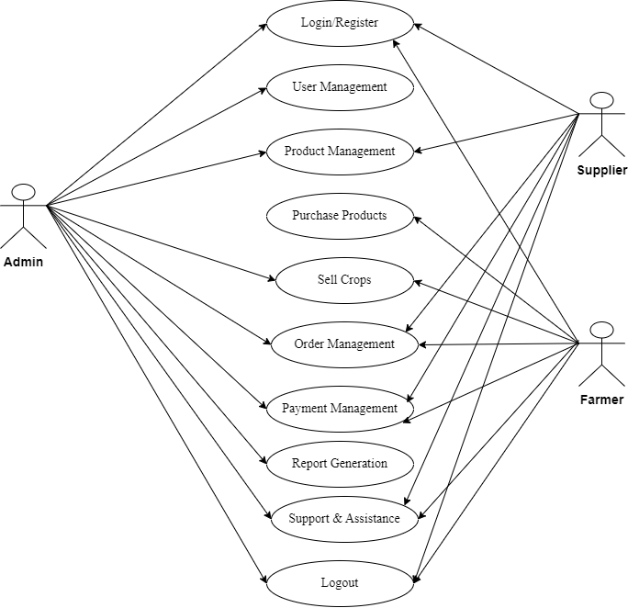

Agriculture Management System

**3.2. Data Dictionary:**

Data Dictionary is a store of information about in database. The dictionary defines the name, description, source of data, users of data, and keyword in data, formula to derive the data, specification and such other details Data Dictionary brings common understanding of the data in the organization.

Data Dictionaries are an integral component of structured of structured analysis, since data flow diagrams by themselves do not fully describe the information about the system. The data dictionary provides additional information about the system.

A data dictionary is a catalogue-repository of the elements in a system. These elements center on data the way they are structured to meet user requirements and organization needs. In a data dictionary, a list of all the elements composing the data flowing through a system is included. Descriptions of all data used in the system are given in a data dictionary.

* **List of all the table in database:**

**Database Name: agrizen**

1. Users
2. Products
3. Orders
4. Order_items
5. Cart
6. Categories
7. Crops
8. Notification

**1) User Table**

**Table Name: User**

**Description:** This Table is store the information about admin

| **Column Name** | **Data Type** | **Constraints** | **Description** | **Example Value** |
| --- | --- | --- | --- | --- |
| user_id | INT (5) | PRIMARY KEY | Unique identifier for each user | 1 |
| Name | VARCHAR (20) | NOT NULL | User name | Green Farms |
| Email | VARCHAR (20) | NOT NULL, UNIQUE | Supplier's email address | supplier@example.com |
| Password_hash | VARCHAR (20) | NOT NULL | Store encrypted password | Xdsfsdf1233w@dsf |
| Role | VARCHAR  (20) | NOT NULL | Admin,Supplier  ,Farmer | Farmer |
| created_at | DATETIME | DEFAULT CURRENT_TIMESTAMP | Timestamp of User registration | 2023-01-05 09:00:00 |

**2) Product Table**

**Table Name: Products**

**Description:** This Table is store the information about product.

|  |  |  |  |  |
| --- | --- | --- | --- | --- |
| **Column Name** | **Data Type** | **Constraints** | **Description** | **Example Value** |
| id | INT(11) | PRIMARY KEY, AUTO_INCREMENT | Unique identifier for each product | 1 |
| name | VARCHAR(255) | NOT NULL | Name of the product | Organic Fertilizer |
| description | TEXT | NULL | Description of the product | A high-quality fertilizer for organic farming. |
| category_id | INT(11) | NULL | Reference to the product category | 2 |
| price | DECIMAL(10,2) | NOT NULL | Price of the product | 25.00 |
| stock_quantity | INT(11) | NOT NULL | Quantity of product in stock | 100 |
| unit | VARCHAR(50) | NOT NULL | Unit of measurement (e.g., kg, lb) | kg |
| image | VARCHAR(255) | NULL | URL or path to the product image | http://example.com/image.jpg |
| status | VARCHAR(20) | NOT NULL DEFAULT 'active' | Status of the product (e.g., active, inactive) | active |
| user_id | INT(11) | NULL | Reference to the supplier | 1 |
| created_at | TIMESTAMP | NOT NULL DEFAULT CURRENT_TIMESTAMP | Timestamp of product entry | 2023-01-15 11:00:00 |
| updated_at | TIMESTAMP | NOT NULL DEFAULT CURRENT_TIMESTAMP ON UPDATE CURRENT_TIMESTAMP | Timestamp of last update | 2023-01-15 11:00:00 |

**3) Order Table**

**Table Name: Orders**

**Description:** This Table is store the information about order.

| **Column Name** | **Data Type** | **Constraints** | **Description** | **Example Value** |
| --- | --- | --- | --- | --- |
| order_id | INT(11) | PRIMARY KEY, AUTO_INCREMENT | Unique identifier for each order | 1 |
| user_id | INT(11) | NOT NULL | Reference to the user placing the order | 123 |
| total_amount | DECIMAL(10,2) | NOT NULL | Total amount for the order | 150.75 |
| order_status | VARCHAR(50) | NULL | Current status of the order | Pending |
| payment_status | VARCHAR(50) | NULL | Current payment status | Unpaid |
| payment_method | VARCHAR(50) | NULL | Method used for payment | Credit Card |
| shipping_address | TEXT | NULL | Address where the order will be shipped | 123 Main St, City, Country |
| created_at | TIMESTAMP | NOT NULL DEFAULT CURRENT_TIMESTAMP | Timestamp when the order was created | 2023-01-15 11:00:00 |
| updated_at | TIMESTAMP | NOT NULL DEFAULT CURRENT_TIMESTAMP ON UPDATE CURRENT_TIMESTAMP | Timestamp of last update | 2023-01-15 11:00:00 |

**4) Order items Table**

**Table Name: Order_items**

**Description:** This Table is store the information about order items details.

| **Column Name** | **Data Type** | **Constraints** | **Description** | **Example Value** |
| --- | --- | --- | --- | --- |
| order_item_id | INT(11) | PRIMARY KEY, AUTO_INCREMENT | Unique identifier for each order item | 1 |
| order_id | INT(11) | NOT NULL | Reference to the associated order | 1 |
| product_id | INT(11) | NOT NULL | Reference to the product being ordered | 101 |
| quantity | INT(11) | NOT NULL | Quantity of the product ordered | 2 |
| price | DECIMAL(10,2) | NOT NULL | Price of the product at the time of order | 25.00 |
| total | DECIMAL(10,2) | NULL, STORED GENERATED | Total cost for this order item (calculated as quantity * price) | 50.00 |

**5) Cart**

**Table Name: cart**

**Description:** This Table is store the information about cart details.

|  |  |  |  |  |
| --- | --- | --- | --- | --- |
| **Column Name** | **Data Type** | **Constraints** | **Description** | **Example Value** |
| cart_id | INT(11) | PRIMARY KEY, AUTO_INCREMENT | Unique identifier for each cart item | 1 |
| user_id | INT(11) | NOT NULL, INDEX | Reference to the user owning the cart | 123 |
| product_id | INT(11) | NOT NULL, INDEX | Reference to the product in the cart | 101 |
| quantity | INT(11) | NOT NULL DEFAULT 1 | Quantity of the product in the cart | 2 |
| price | DECIMAL(10,2) | NOT NULL | Price of the product at the time of addition to the cart | 25.00 |
| total | DECIMAL(10,2) | NULL, STORED GENERATED | Total cost for this cart item (calculated as quantity * price) | 50.00 |
| created_at | TIMESTAMP | NOT NULL DEFAULT CURRENT_TIMESTAMP | Timestamp when the cart item was created | 2023-01-15 11:00:00 |
| updated_at | TIMESTAMP | NOT NULL DEFAULT CURRENT_TIMESTAMP ON UPDATE CURRENT_TIMESTAMP | Timestamp of last update | 2023-01-15 11:00:00 |

**6) Categories**

**Table Name: categories**

**Description:** This Table is store the information about categories details.

|  |  |  |  |  |
| --- | --- | --- | --- | --- |
| **Column Name** | **Data Type** | **Constraints** | **Description** | **Example Value** |
| id | INT(11) | PRIMARY KEY, AUTO_INCREMENT | Unique identifier for each record | 1 |
| name | VARCHAR(255) | NOT NULL | Name of the entity | Sample Entity Name |
| description | TEXT | NULL | Description of the entity | This is a sample entity used for demonstration purposes. |
| user_id | INT(11) | NULL | Reference to the user associated with the entity | 123 |
| status | ENUM('active', 'inactive') | NULL, DEFAULT 'active' | Current status of the entity | active |
| created_at | TIMESTAMP | NOT NULL DEFAULT CURRENT_TIMESTAMP | Timestamp when the record was created | 2023-01-15 11:00:00 |
| updated_at | TIMESTAMP | NOT NULL DEFAULT CURRENT_TIMESTAMP ON UPDATE CURRENT_TIMESTAMP | Timestamp of last update | 2023-01-15 11:00:00 |

**7) Crop Table**

**Table Name: crops**

**Description:** This Table is store the information about crop.

| **Column Name** | **Data Type** | **Constraints** | **Description** | **Example Value** |
| --- | --- | --- | --- | --- |
| id | INT(11) | PRIMARY KEY, AUTO_INCREMENT | Unique identifier for each crop | 1 |
| name | VARCHAR(255) | NOT NULL | Name of the crop | Organic Wheat |
| variety | VARCHAR(255) | NOT NULL | Variety of the crop | Hard Red Winter Wheat |
| season | VARCHAR(100) | NOT NULL | Season in which the crop is grown | Spring |
| duration_days | INT(4) | NOT NULL | Duration of growth in days | 120 |
| region | VARCHAR(255) | NOT NULL | Region where the crop is cultivated | Midwest USA |
| soil_type | VARCHAR(100) | NOT NULL | Type of soil suitable for the crop | Loamy |
| sowing_method | VARCHAR(100) | NOT NULL | Method used for sowing | Direct Seeding |
| yield_kg_per_hectare | INT(6) | NOT NULL | Expected yield in kg per hectare | 3000 |
| description | TEXT | NULL | Description of the crop | A high-yielding variety suitable for various climates. |
| created_at | TIMESTAMP | NOT NULL DEFAULT CURRENT_TIMESTAMP | Timestamp when the record was created | 2023-01-15 11:00:00 |
| updated_at | TIMESTAMP | NOT NULL DEFAULT CURRENT_TIMESTAMP ON UPDATE CURRENT_TIMESTAMP | Timestamp of last update | 2023-01-15 11:00:00 |
| image | VARCHAR(255) | NULL | URL or path to the crop image | http://example.com/crop.jpg |

**8) Notification Table**

**Table Name: notification**

**Description:** This Table is store the information about supplier notification.

| **Column Name** | **Data Type** | **Constraints** | **Description** | **Example Value** |
| --- | --- | --- | --- | --- |
| notification_id | INT (5) | PRIMARY KEY | Unique identifier for each notification | 1 |
| user_id | INT (5) | NOT NULL | Reference to the farmer | 1 |
| message | TEXT | NOT NULL | Notification message | New training session available |
| date_sent | DATETIME | NOT NULL | Date when the notification was sent | 2023-03-02 09:00:00 |
|  |  |  |  |  |

* **Development**

**4.1. Coding Standards:**

**4.1.1. PSP Standards:** Follow PHP-FIG's PSR (PHP Standards Recommendations), especially:

* + **PSR-1:** Basic coding standard.
  + **PSR-2:** Coding style guide.
  + 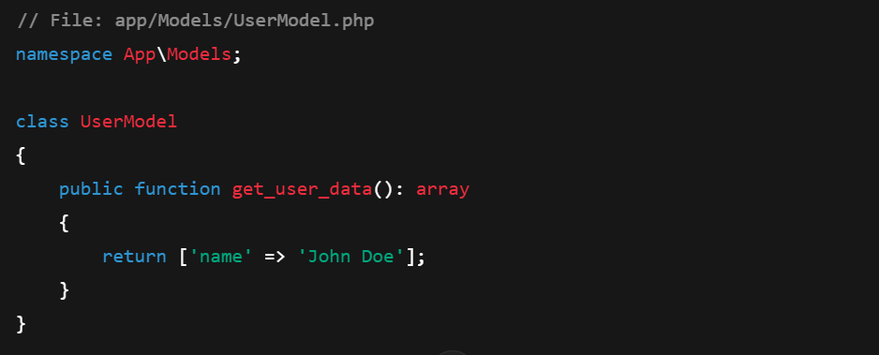**PSR-4:** Autoloading standard.

**4.1.2. Naming Conventions:**

* Use CamelCase for class names (e.g., User Model).
* Use snake_case for method and variable names (e.g., get_user_data).
* Use descriptive names for variables and functions.

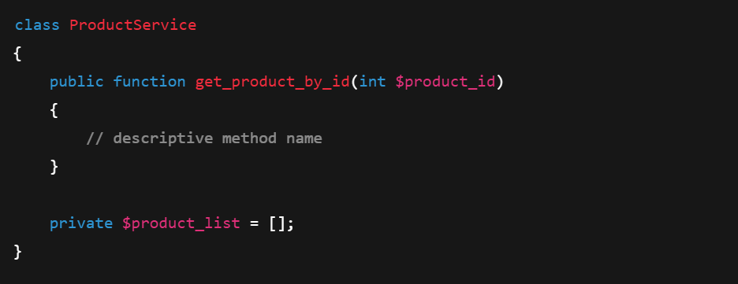

**4.1.3. File Structure:**

* Organize files in a logical directory structure (e.g., controllers, models, views).
* Keep configuration files separate and organized.

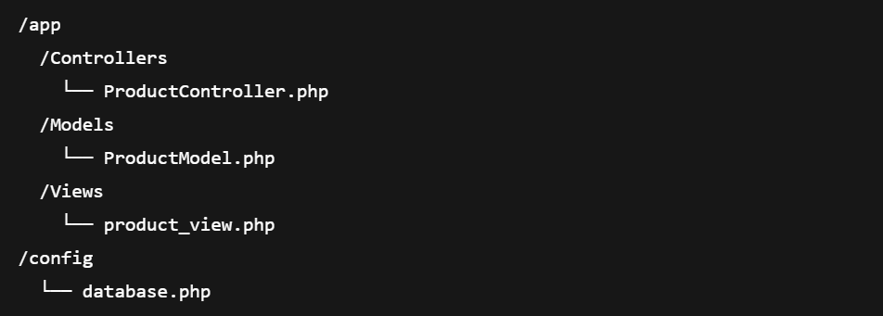

**4.1.4. Comments and Documentation:**

* Use comments to explain complex logic.
* Utilize PHPDoc for documenting classes and methods.

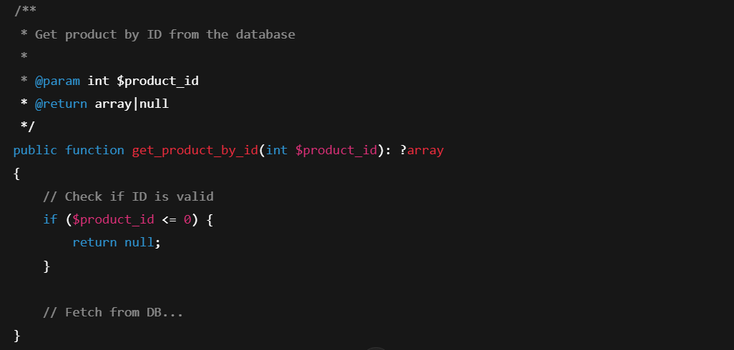

**4.1.5. Error** **Handling:**

* Implement proper error handling using try-catch blocks.
* 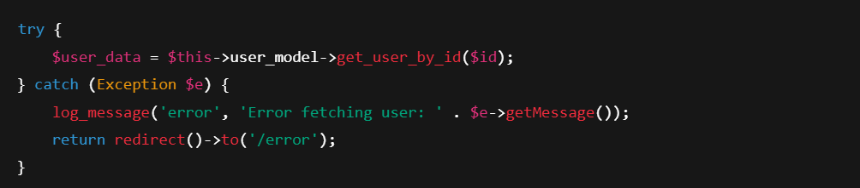Use logging for errors instead of displaying them to users.

**4.1.6. Security Practices:**

* Sanitize and validate user inputs to prevent SQL injection and XSS.
* Use CodeIgniter's built-in functions for escaping output.

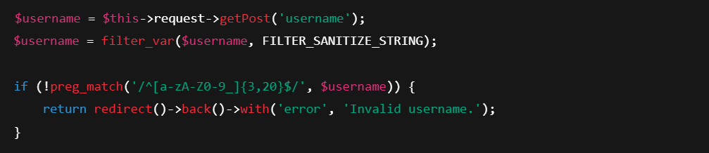

**4.2. Screen Shots:**

**1) Login page:**

* A simple login form requiring an email and password with options for account creation.

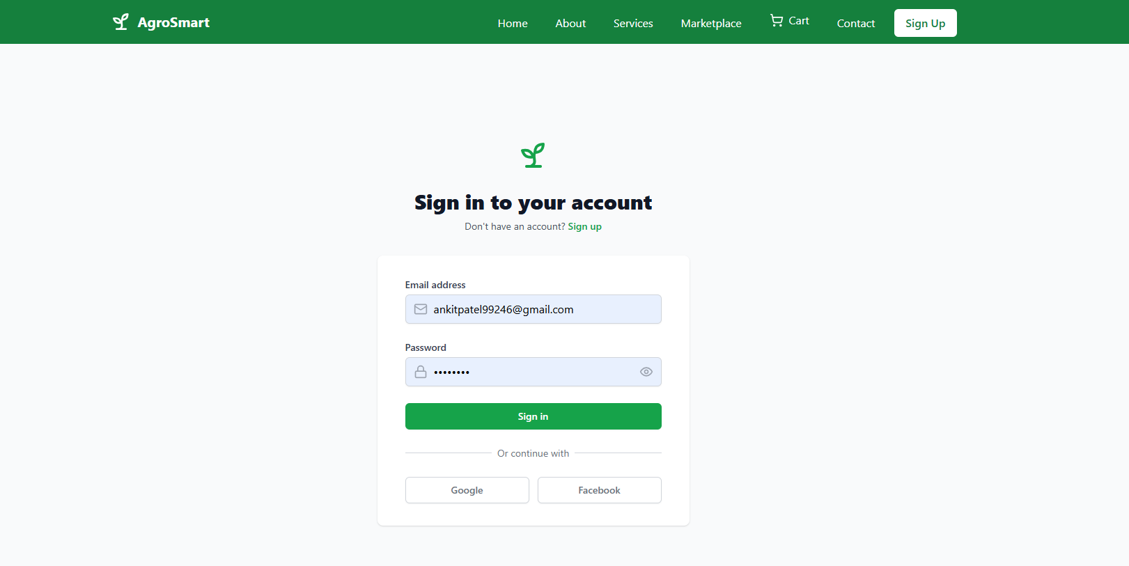

**2) Register Page:**

* A user registration form with fields for first name, last name, email, password and confirm password. Required field errors are displayed.

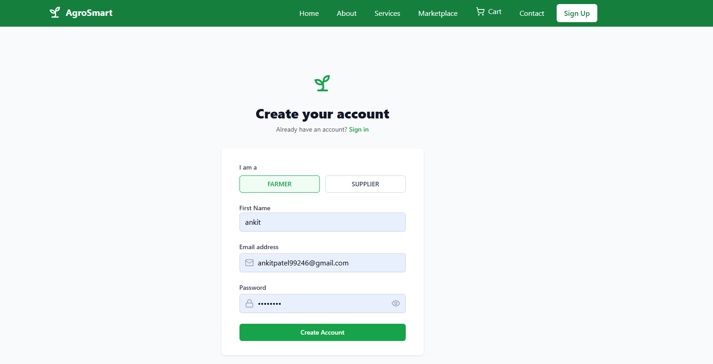

**3) Home Page:**

* This image showcases the homepage of "AgroSmart," a smart farming platform. It highlights modern agricultural solutions with options to get started or learn more.

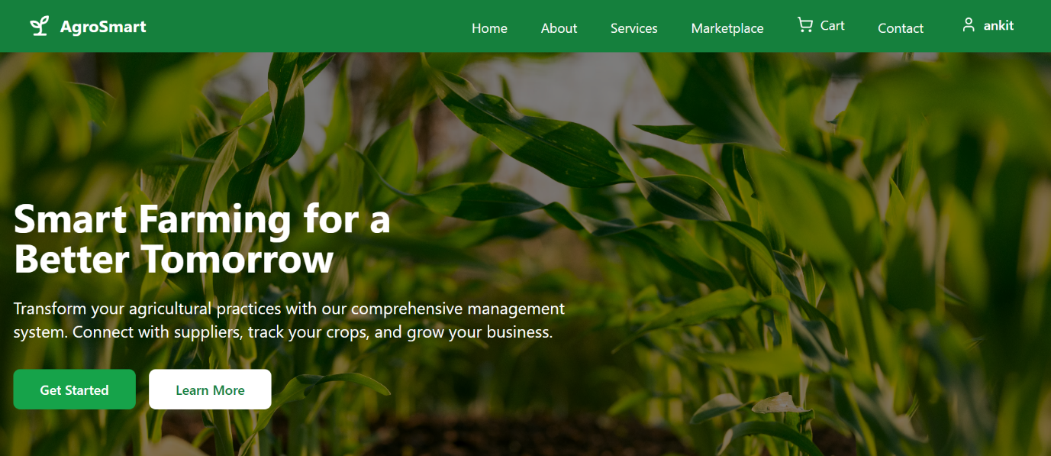

**4) Over Service:**

* This image presents the "Our Services" section of AgroSmart, showcasing crop management, market analytics, and weather insights for modern agriculture.

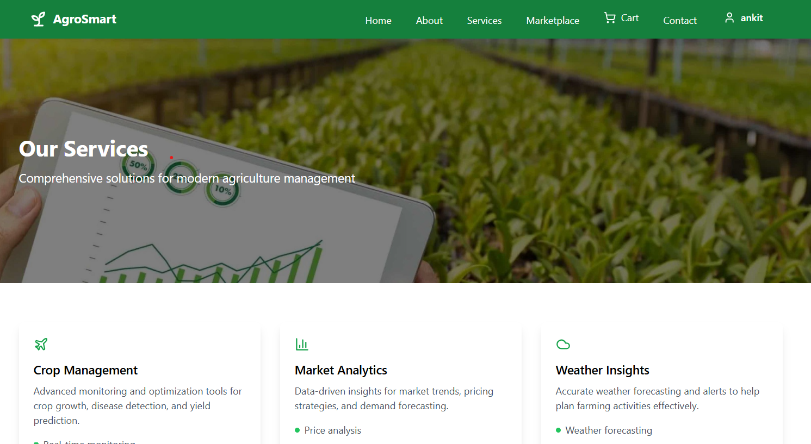

**5) Marketplace:**

* This image presents the "Marketplace" section of AgroSmart, showcasing crop management, market price, for modern agriculture.

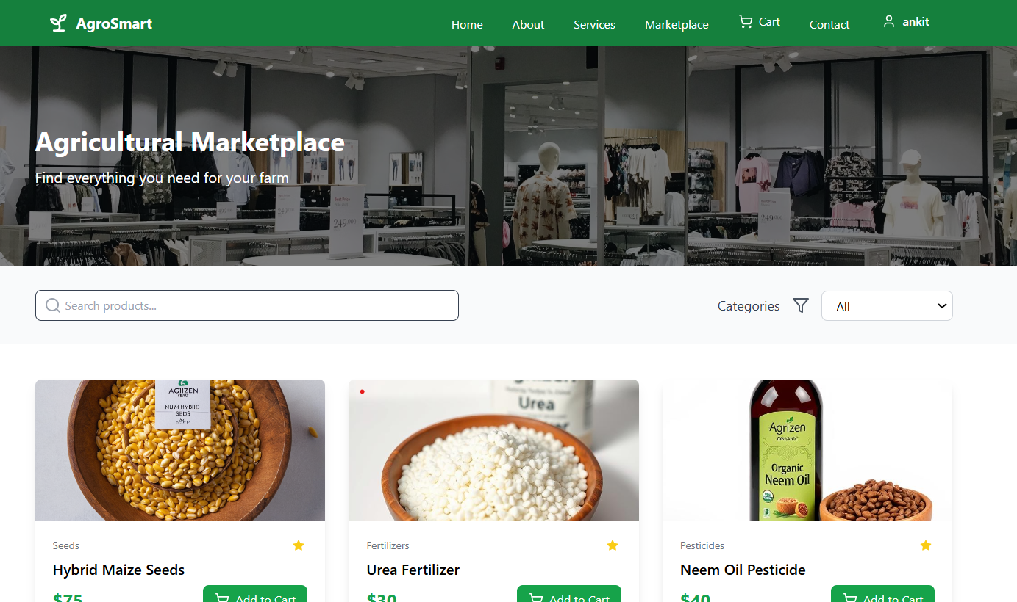

**6) Contact Us:**

* This image represents the "Contact Us" page of AgroSmart, featuring a message form and contact details, including address, phone, email, and business hours.

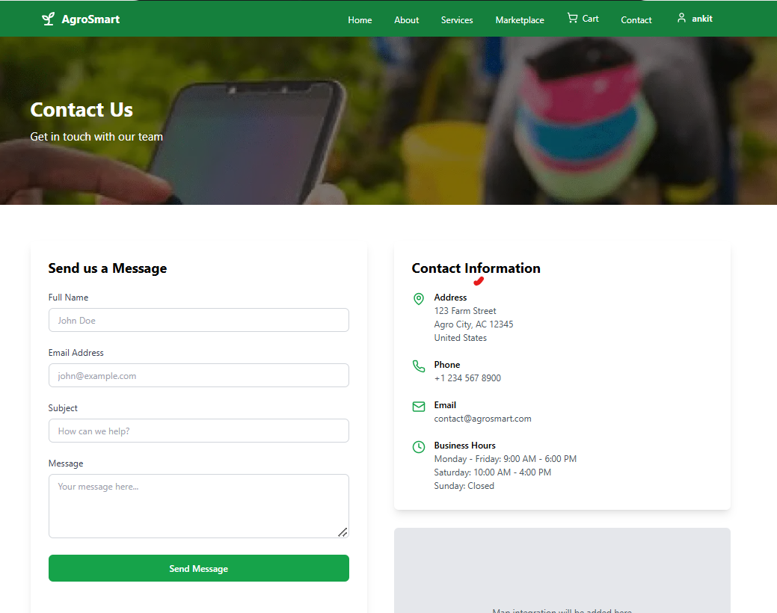

**7) Admin Dashboard:**

* This image represents an "Admin Dashboard" for AgroSmart, displaying key agricultural metrics, recent activities, and upcoming tasks for farm management.

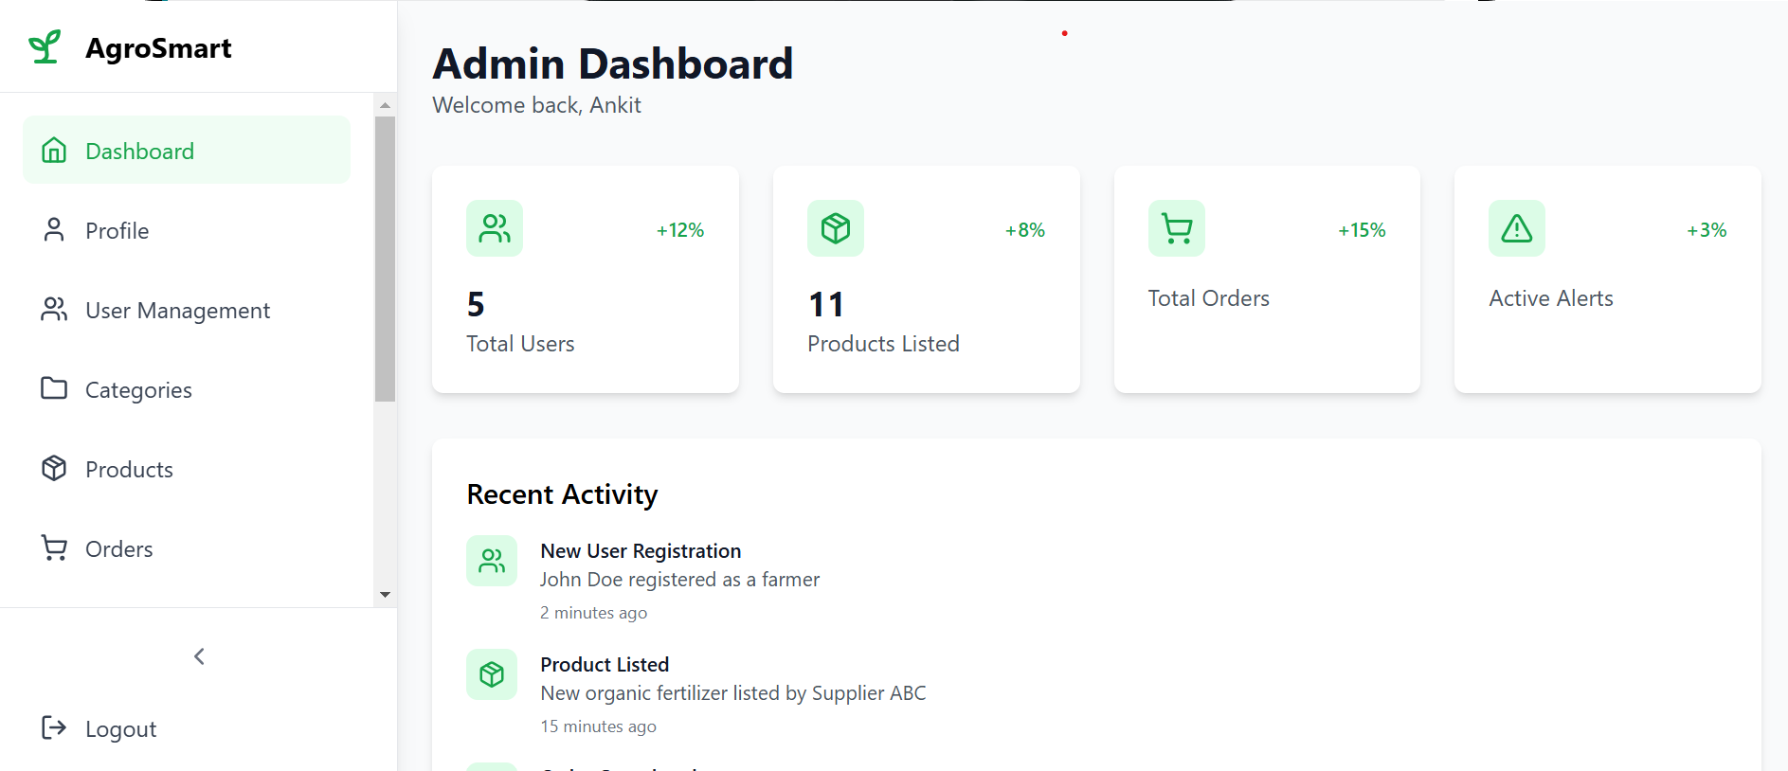

**8) Admin profile:**

* The image shows the **Admin Profile** section where the admin can view their name, email, and role. It also provides options to **edit profile details** and **change the account password**.

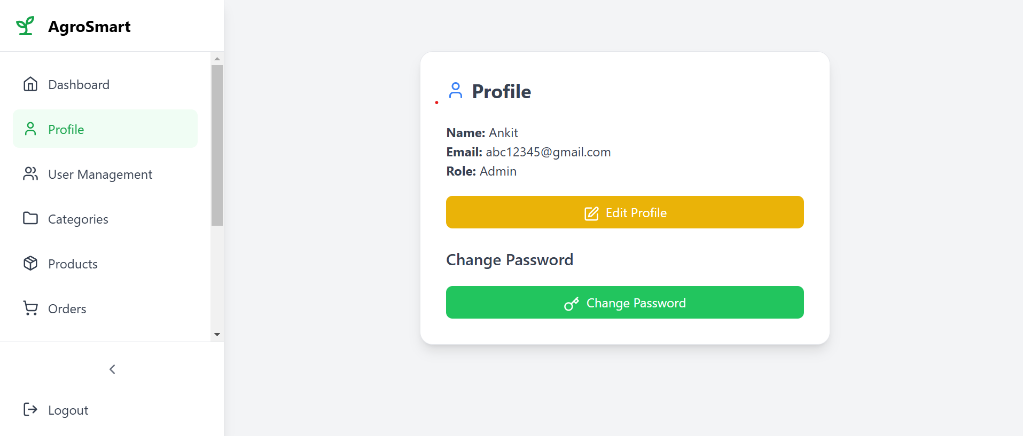

**9) Admin User Management:**

* The image displays the **User Management** section where admins can add new users by entering their details.  
  It also shows a user list with options to **edit or delete** each user's information and role.

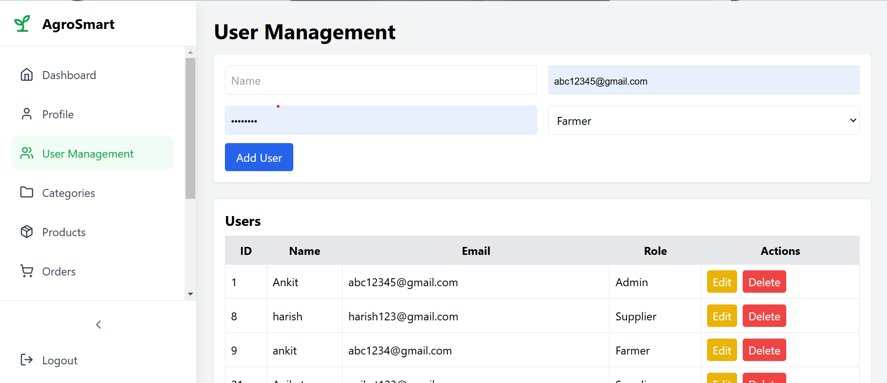

**10) Admin Categories:**

* The interface includes fields for entering a new category name and a description, along with an "Add Category" button for submission.

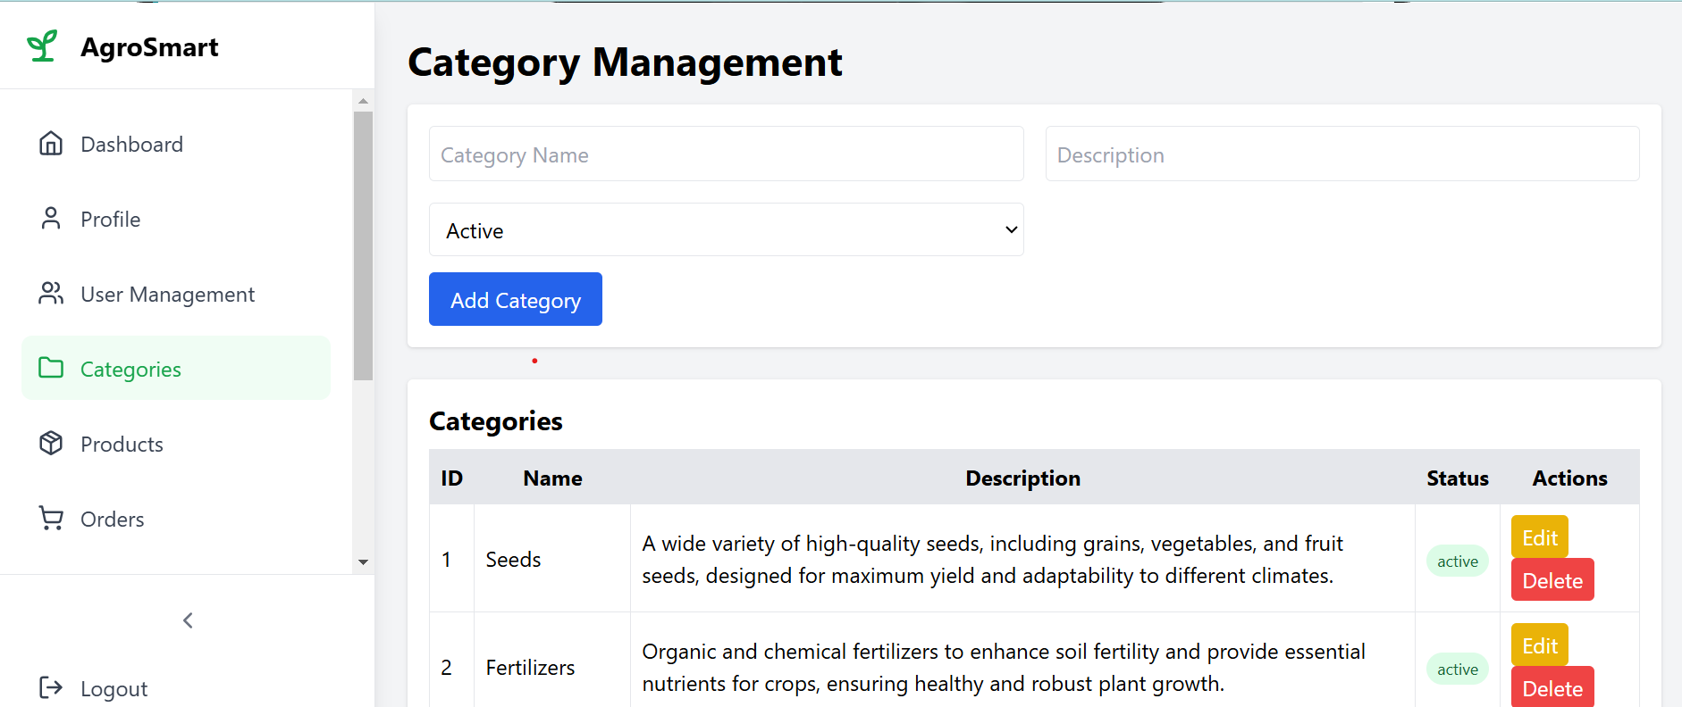

**11) Admin product management:**

* This part of the application allows users to enter details for new products, including the product name, category, description, price, stock quantity, and a product image.

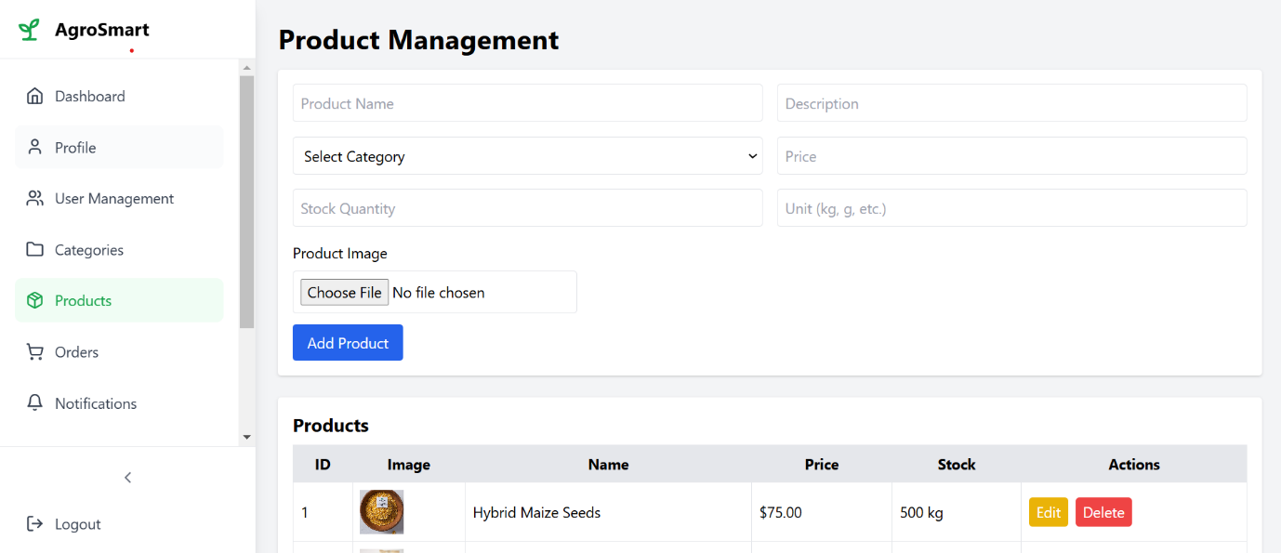

**12) Supplier Dashboard:**

* This image represents a "Supplier Dashboard" for AgroSmart, displaying key metrics such as total products, active orders, revenue, and pending queries.

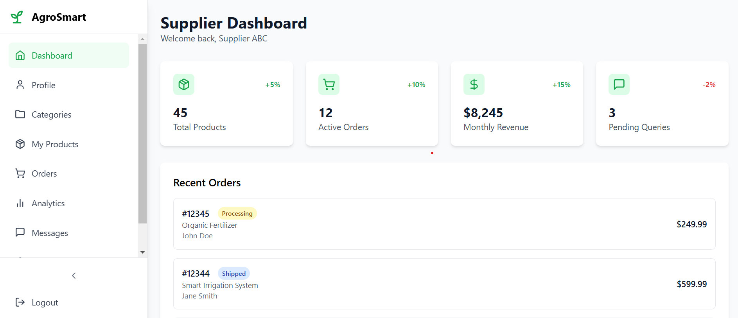

**13) Supplier profile:**

* The interface displays Supplier profile information including name, email, and role (Supplier).
* Supplier can edit their profile and change their password through clearly labeled buttons.

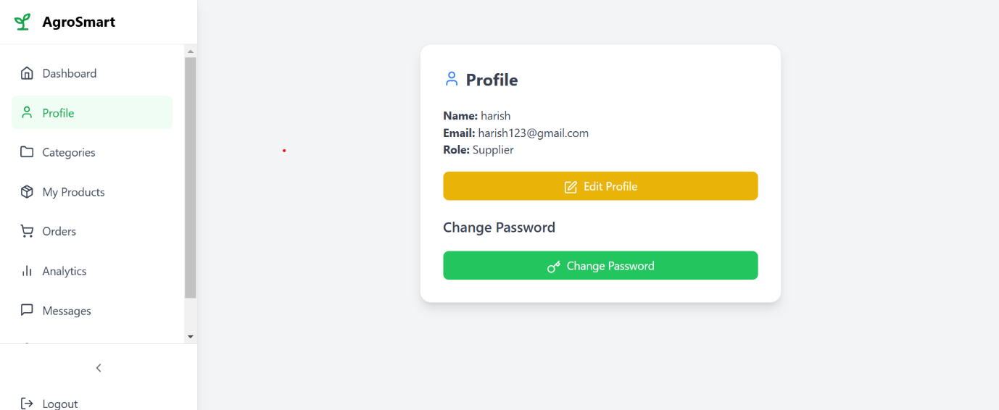

**14) Supplier categories:**

* The interface allows users to manage different agricultural product categories, such as Seeds, Fertilizers, and Pesticides.

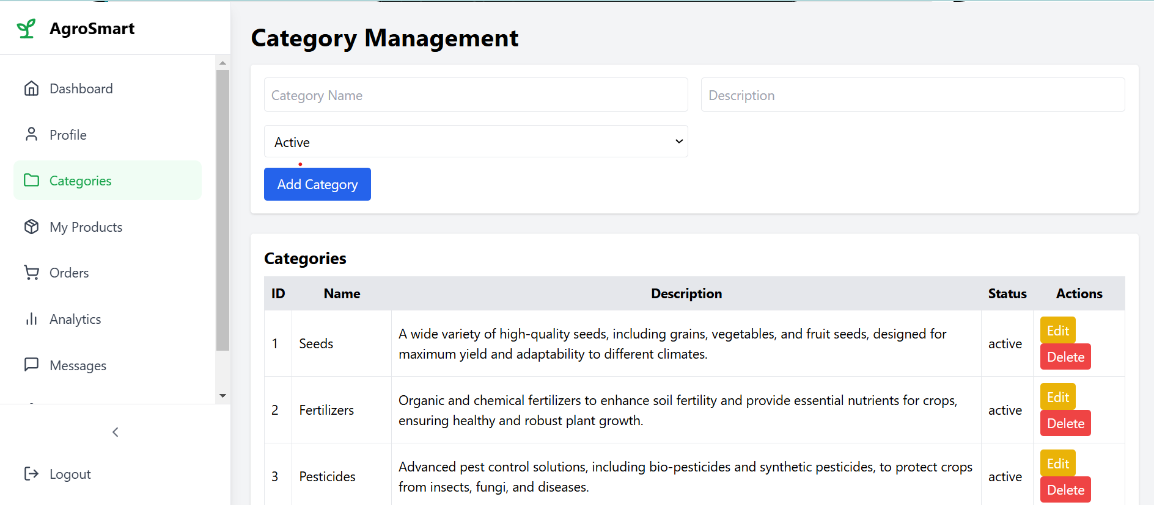

**15) Supplier product management:**

* The interface allows users to manage different agricultural product categories, such as Seeds, Fertilizers, and Pesticides.

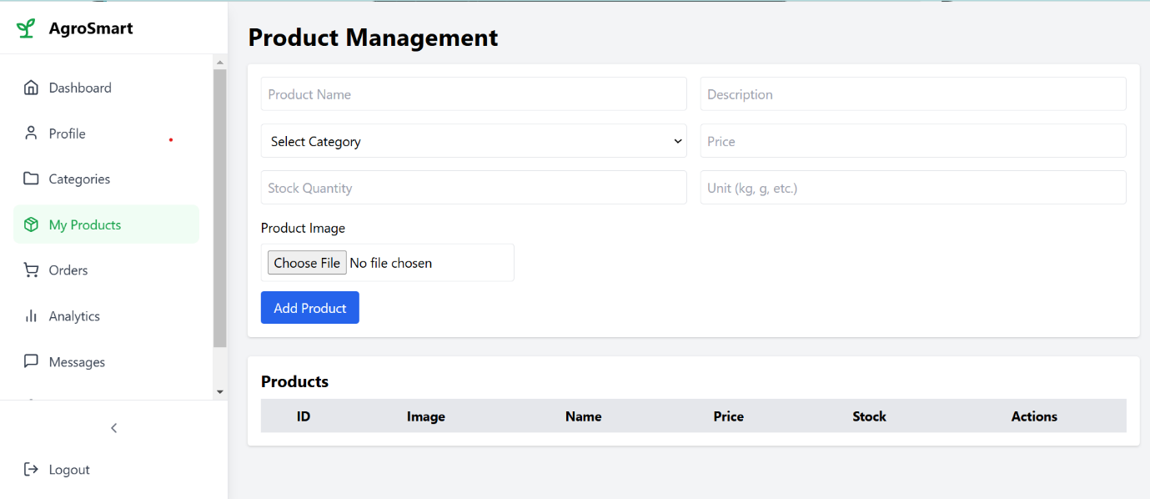

* **Agile Document**

**5.1. Agile Project Charter:**

|  |  |
| --- | --- |
| **Agile Project Charter** | |
|  |  |
| **Project Name:** | **Agriculture Management System** |
| **Project Champion:** | Ankit Khavadiya, Amit Chudesara, Simun Saiyed |
| **Project Sponsor:** | LJ institute of computer application |
| **Project Manager:** | Dr. Bhavin shah |
| **Expected Start Date:** | 1 Jan 2025 |
| **Expected Completion Date:** | 20 march 2025 |
|  |  |
| **Project Goal:** | The **goal of an Agriculture Management System** is to enhance efficiency, productivity, and sustainability in farming operations by leveraging technology. The system aims to help farmers, agribusinesses, and stakeholders manage resources effectively, monitor crop and livestock conditions, and make data-driven decisions. |
|  |  |
| **Project Vision:** | The **vision** of the Agriculture Management System is to revolutionize the agricultural sector by integrating smart technology, automation, and data-driven insights to enhance productivity, sustainability, and profitability for farmers and agribusinesses. |
|  |  |
| **Project Scope:** | The **scope** of the Agriculture Management System defines its features, functionalities, and limitations. This system aims to provide a comprehensive solution for farmers, agribusinesses, and stakeholders to efficiently manage agricultural activities. |
|  |  |
| **Key Stakeholders:** | The **Admin** oversees system management, user access, and overall platform maintenance. The **Farmer** utilizes the system for crop planning, resource management, and market access, while the **Supplier** provides essential farming inputs like seeds, fertilizers, and equipment, ensuring a smooth supply chain. |
|  |  |
| **Risk** | Potential risks for the Agriculture Management System include **data security threats, system downtime, resistance to technology adoption, unreliable internet connectivity in rural areas, and inaccurate data affecting decision-making.** |

**5.2. Agile Roadmap / Schedule:**

|  |  |  |  |
| --- | --- | --- | --- |
| **Agile Roadmap/Schedule for Agriculture Management System(AMS)** | | | |
|  |  |  |  |
|  | **Duration** | **Theme/Epic** | **Features** |
|  |  |  |  |
| **Phase 1: Planning & Design** | Week 1 | Requirement Gathering & System Planning | Define scope, gather requirements, finalize tech stack, design database schema, UI/UX wireframes. |
| Week 2 | System Architecture & UI/UX Design | Design database schema, UI/UX wireframes, and set up development environment. |
| **Phase 2:**  **Core**  **Development** | Week 3 | Admin Module | Admin dashboard, user role management, system configuration, reports, and security settings. |
| Week 4 | Farmer Module | Farmer registration, profile management, and Buy Product and  Sell crop. |
| Week 5 | Supplier | Supplier registration, Product sell and buy crop. |
| Week 6 | Placement Staff Module | Placement cell dashboard, job approvals, student tracking, analytics. |
| **Phase 3:**  **Testing & Refinement** | Week 7 | System Testing & Refinement | Unit testing for Admin, Farmer, and Supplier modules. |
| Week 8 | Integration Testing & Compliance Review | Integration testing, data security validation, role-based access verification. |
| **Phase 4: Deployment & UAT** | Week 9 | User Acceptance Testing (UAT) | User Acceptance Testing (UAT), collect feedback, fix bugs, optimize performance. |
| **Phase 5:**  **Final Deployment & Support** | Week 10 | Go-Live & Post-Deployment Support | Full system deployment, real-time monitoring, and ongoing maintenance. |

**5.3. Agile Project Plan:**

|  |  |  |  |  |  |  |  |  |
| --- | --- | --- | --- | --- | --- | --- | --- | --- |
| **AGILE PROJECT PLAN TEMPLATE** | | | | | | | | |
| **PROJECT NAME** | **Agriculture Management System** |  |  |  |  | **START DATE** | **END DATE** | **OVERALL PROGRESS** |
| **PROJECT MANAGER** | Dr. Bhavin shah |  |  |  |  | ! Jan 2025 |  |  |
|  |  |  |  |  |  |  |  |  |
| **AT RISK** | **TASK NAME** | **RESPONSIBLE** | **STORY POINTS** | **START** | **FINISH** | **DURATION** in days | **STATUS** | **COMMENTS** |
|  |  |  |  |  |  |  |  |  |
|  | SPRINT 1 |  |  | 01-Jan-25 | 19‐Jan‐25 | 19 | Completed |  |
| No | Gather Information | All | 0 | 01-Jan-25 | 4-Jan-25 | 4 | Completed | Initial data gathering |
| No | Identify Stackholders | All | 0 | 5-Jan-25 | 7-Jan-25 | 3 | Completed | Identifying users & role |
| No | Define System Architecture | All | 0 | 8-Jan-25 | 11-Jan-25 | 4 | Completed | Defining architecture for scalability |
| No | Design Database Schema | All | 0 | 12-Jan-25 | 15-Jan-25 | 4 | Completed | Designing database relations |
| No | Create UI/UX | All | 0 | 16-Jan-25 | 19-Jan-25 | 4 | Completed | Creating UI mockups |
|  |  |  |  |  |  |  |  |  |
|  | SPRINT 2 |  |  | 20-Jan-25 | 06-Feb-25 | 17 | Completed | Admin |
| No | Develop Admin Dashboard | Ankit khavadiya | 1 | 20-Jan-25 | 22-Jan-25 | 3 | Completed | Counted data |
| Yes | Supplier Management | Amit Chudesara | 3 | 23-Jan-25 | 26-Jan-25 | 4 | Completed | Add, Approve/Reject |
| Yes | Student Management | Saiyed Simun | 3 | 27-Jan-25 | 30-Jan-25 | 4 | Completed | Add/Delete |
| No | Farmer Management | Ankit Khavadiya | 1 | 01-Feb-25 | 03-Feb-25 | 3 | Completed | Add/View |
| Yes | Approve/Reject Job | Amit  Chudesara | 2 | 04-Feb-25 | 06-Feb-25 | 3 | Completed | Add/View/Delete |
|  |  |  |  |  |  |  |  |  |
|  | SPRINT 3 |  |  | 07-Feb-25 | 22-Feb-25 | 16 | Completed | Supplier |
| No | Profile Management | Ankit Khavadiya | 1 | 07-Feb-25 | 09-Feb-25 | 3 | Completed | Counted data |
| Yes | Product management | Amit Chudesara | 3 | 10-Feb-25 | 12-Feb-25 | 3 | Completed | Add/Delete/Edit |
| Yes | Order Management | Simun Saiyed | 4 | 13-Feb-25 | 15- Feb -25 | 3 | Completed | Date/ time , location |
| Yes | Analytics | Ankit Khavadiya | 2 | 16-Feb-25 | 18- Feb -25 | 3 | Completed | Round wise |
| Yes | Massages | Amit Chudesara | 2 | 19-Feb-25 | 20- Feb -25 | 2 | Completed | Excel file |
| No | Revenue | Simun Saiyed | 1 | 21-Feb-25 | 22-Feb-25 | 2 | Completed | status |
|  |  |  |  |  |  |  |  |  |
|  | SPRINT 4 |  |  | 23-Feb-25 | 12-Mar-25 | 19 | Completed | Farmer |
| Yes | Farmer Login/Register/Home Page | Amit Chudesara , Ankit Khavadiya | 4 | 23-Feb-25 | 26-Feb-25 | 5 | Completed |  |
| Yes | View Product | Simun Saiyed | 5 | 27-Feb-25 | 1-Mar-25 | 3 | Completed | Role/company |
| yes | Add to cart | Ankit Khavadiya | 5 | 02-Mar-25 | 04-Mar-25 | 3 | Completed | Round wise |
| No | Apply For Supplier | Saiyed Simun | 1 | 05-Mar-25 | 06-Mar-25 | 2 | Completed | Schedule interview |
| yes | View Notification | Amit Chudesara | 2 | 07-Mar-25 | 09-Mar-25 | 3 | Completed | About job/interview |
| No | About us/Feedback | Ankit Khavadiya | 0 | 10-Mar-25 | 12-Mar-25 | 3 | Pending | Feedback/review |

**5.4. Agile User Story (Minimum 3 Tasks):**

|  |  |  |  |  |
| --- | --- | --- | --- | --- |
| **User Story ID** | **Priority** | **As a (User Type)** | **I want to (Task)** | **So that I can (Goal)** |
| **1** | **High** | **Farmer** | **Register and log in to the system** | **Access my farm data securely** |
| **2** | **High** | **Admin** | **Manage user roles and permissions** | **Ensure secure and appropriate access to the system** |
| **3** | **Medium** | **Supplier** | **Register my business** | **Offer agricultural products to farmers** |
| 4 | **High** | **Farmer** | **Add and update farm details** | **Keep track of my farm’s crops and soil conditions** |
| **5** | **High** | **Farmer** | **Receive weather updates** | **Plan my farming activities effectively** |
| **6** | **Medium** | **Supplier** | **Manage inventory of seeds and fertilizers** | **Keep track of available stock** |
| **7** | **High** | **Admin** | **View reports and analytics** | **Monitor system usage and farm productivity** |
| **8** | **Medium** | **Farmer** | **Schedule irrigation reminders** | **Ensure proper watering for my crops** |
| **9** | **High** | **Supplier** | **Process and track orders** | **Deliver farming supplies efficiently** |
| **10** | **High** | **Farmer** | **Request farming equipment** | **Easily access necessary tools for farming** |
| **11** | **Medium** | **Admin** | **Approve or reject supplier registrations** | **Maintain system integrity and reliability** |
| **12** | **Medium** | **Farmer** | **Track expenses and sales** | **Manage my farm’s financial performance** |
| **13** | **High** | **Farmer** | **Receive pest and disease alerts** | **Take preventive actions to protect crops** |
| **14** | **High** | **Admin** | **Generate system-wide reports** | **Analyze performance and usage trends** |
| **15** | **Medium** | **Farmer** | **Communicate with suppliers and other farmers** | **Exchange knowledge and make informed decisions** |

**5.5. Agile Release Plan**

* **What is agile release plan?**

An Agile release plan is a method for planning, directing, and releasing projects in increments.

* **How does it work?**

Break down work: Agile release planning breaks down large projects into smaller, more manageable chunks called sprints.

Prioritize: Prioritize backlog items to deliver benefits, not just features.

Plan sprints: Work in short sprints and set realistic sprint goals.

Plan releases: Set flexible release dates to avoid unnecessary pressure.

Track progress: Keep track of important milestones, tasks, and deliverables.

An **Agile Release Plan** is a high-level roadmap that outlines how a product will be developed, delivered, and improved over time. It aligns the team's goals with business objectives and provides visibility into the scope, priorities, and timelines. The release plan is typically reviewed and adjusted regularly to reflect changes in priorities, feedback, or unforeseen challenges.

|  |  |  |  |  |  |  |  |  |  |
| --- | --- | --- | --- | --- | --- | --- | --- | --- | --- |
| Risk Level | Sprint | Task Name | Description | Start Time | Finish Time | Duration (Days) | Story Points | Status | Release Date |
| Medium | 1 | Requirement Gathering & System Planning | Define scope, gather requirements, finalize tech stack, design database schema, UI/UX wireframes. | 2025-01-01 | 2025-01-04 | 4 | 0 | Completed | 2025-03-28 |
| High | 1 | System Architecture & UI/UX Design | Design database schema, UI/UX wireframes, and set up development environment. | 2025-01-08 | 2025-01-19 | 12 | 0 | Completed | 2025-03-28 |
| Medium | 2 | Farm Data Management Module | Develop features for recording and managing farm data, including crop and livestock information. | 2025-01-20 | 2025-02-06 | 17 | 3 | Completed | 2025-03-28 |
| High | 3 | Weather and Soil Integration | Integrate APIs for real-time weather updates and soil quality assessments. | 2025-02-07 | 2025-02-22 | 16 | 4 | Completed | 2025-03-28 |
| Medium | 4 | Irrigation Management Module | Implement scheduling and monitoring of irrigation activities. | 2025-02-23 | 2025-03-12 | 19 | 5 | Completed | 2025-03-28 |
| Low | 5 | Pest and Disease Tracking | Develop tools for tracking and managing pest infestations and crop diseases. | 2025-03-13 | 2025-03-20 | 8 | 3 | Completed | 2025-04-05 |
| High | 6 | User Authentication and Security | Implement secure login, role-based access, and data protection measures. | 2025-03-21 | 2025-03-27 | 7 | 2 | Completed | 2025-04-05 |
| Medium | 7 | Mobile Responsiveness | Optimize the system for mobile devices to facilitate on-the-go access. | 2025-03-28 | 2025-04-03 | 7 | 3 | Completed | 2025-04-12 |
| Low | 8 | User Training and Documentation | Develop user manuals and conduct training sessions for end-users. | 2025-04-04 | 2025-04-10 | 7 | 4 | Pending | 2025-04-19 |

**5.6. Agile Sprint Backlog:**

The Sprint Backlog is a crucial component of Agile and Scrum methodologies, serving as a detailed plan for a specific sprint in the Agriculture Management System development. It consists of selected user stories, tasks, and bug fixes that the development team commits to completing within a sprint cycle (typically 1-4 weeks).

The Sprint Backlog is created during Sprint Planning, where the team selects relevant items from the Product Backlog based on the sprint goal. In the case of an Agriculture Management System, this could include features such as farm registration, crop tracking, weather monitoring, irrigation scheduling, and pest control management.

Each backlog item is broken down into smaller, manageable tasks, with estimated effort points assigned. The team continuously updates and tracks the Sprint Backlog using tools like Jira, Trello, or Kanban boards, ensuring transparency and enabling the team to monitor progress efficiently.

Unlike the Product Backlog, which evolves throughout the project, the Sprint Backlog remains relatively stable during the sprint. However, minor refinements can be made when necessary, such as adjusting the irrigation scheduling logic or fine-tuning crop monitoring algorithms.

A Daily Scrum (stand-up meeting) helps the team review progress and address obstacles, such as integration issues with weather APIs or delays in database setup for farm data.

At the end of the sprint, the team conducts:

* A Sprint Review to demonstrate completed features, such as automated pest control alerts or a farm productivity dashboard.
* A Sprint Retrospective to discuss improvements for future sprints, like optimizing data entry workflows for farmers or improving system performance for large-scale farms.

|  |  |  |  |  |  |  |  |  |  |  |  |
| --- | --- | --- | --- | --- | --- | --- | --- | --- | --- | --- | --- |
| **Sprint Backlog ID** | **Backlog Task** | **User Story** | **Story Points** | **Assigned To** | **Status** | **Original Estimate (Days)** | **Day 1** | **Day 2** | **Day 3** | **Day 4** | **Day 5** |
| SB-001 | Farmer Registration & Login | As a farmer, I want to register and log in to access the agriculture portal. | 5 | Amit Chudesara | Completed | 3 | 5 | 3 | 1 | 0 | - |
| SB-002 | Crop Selling System | As a farmer, I want to list my crops for sale to reach buyers. | 4 | Simun Saiyed | Completed | 3 | 4 | 3 | 2 | 0 | - |
| SB-003 | Buyer Registration | As a buyer, I want to register and log in to purchase crops. | 3 | Ankit Khavadiya | Completed | 3 | 3 | 2 | 1 | 0 | - |
| SB-004 | Order Scheduling | As a buyer, I want to schedule crop purchases for better coordination. | 4 | Amit Chudesara | Completed | 5 | 4 | 3 | 1 | 0 | - |
| SB-005 | Approve/Reject Crop Listings | As an admin, I want to approve or reject crop listings to manage quality. | 2 | Amit Chudesara | Completed | 3 | 3 | 2 | 1 | 0 | - |
| SB-006 | Manage Crop Listings | As a farmer, I want to add, edit, and delete crop listings. | 3 | Amit Chudesara | Completed | 3 | 3 | 3 | 1 | 0 | - |
| SB-007 | Shortlist Buyers | As a farmer, I want to shortlist buyers based on their offers. | 2 | Simun Saiyed | Completed | 3 | 3 | 2 | 1 | 0 | - |
| SB-008 | View Crop Orders | As a farmer, I want to view orders placed for my crops. | 1 | Amit Chudesara | Completed | 2 | 2 | 1 | 1 | 0 | - |
| SB-009 | View Notifications | As a farmer, I want to receive notifications about market trends and orders. | 2 | Simun Saiyed | Completed | 3 | 3 | 2 | 1 | 0 | - |
| SB-010 | Generate Sales Reports | As a farmer, I want to generate reports of my crop sales. | 2 | Ankit Khavadiya | Completed | 2 | 2 | 2 | 1 | 0 | - |
| SB-011 | Feedback & Reviews | As a buyer, I want to submit feedback about the purchasing process. | 1 | Ankit Khavadiya | Completed | 3 | 3 | 2 | 1 | 0 | - |
| SB-012 | Agriculture Officer Dashboard | As an agriculture officer, I want to manage farmer registrations and sales data. | 5 | Ankit Khavadiya | Completed | 5 | 5 | 4 | 3 | 0 | - |
| SB-013 | Admin Management | As an admin, I want to oversee crop sales and ensure system security. | 5 | Simun Saiyed | Completed | 5 | 3 | 3 | 2 | 0 | - |
| SB-014 | View Farmer Profiles | As a buyer or admin, I want to view farmer profiles to evaluate their credibility. | 2 | Amit Chudesara | Pending | 2 | 1 | 1 | 1 | 1 | Pending |
| SB-015 | Forgot Password | As a user, I want to reset my password so that I can regain access if I forget it. | 7 | Simun Saiyed | Pending | 5 | 5 | 4 | 3 | 2 | Pending |

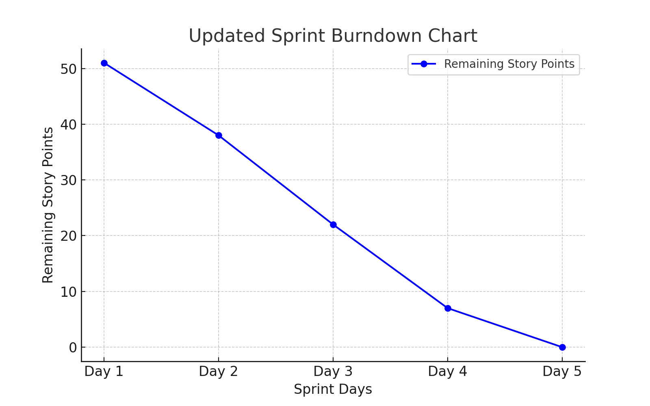

**5.7. Agile Test Plan:**

An **Agile Test Plan** is a flexible testing strategy used in Agile development. It focuses on continuous testing throughout sprints to ensure quality and quick feedback.

Instead of a fixed document, it evolves with the project, emphasizing collaboration, automation, and frequent testing to catch issues early.

An **Agile Test Plan** is a dynamic and iterative testing approach in Agile development.

It ensures continuous validation of features throughout sprints, focusing on flexibility, collaboration, and quick feedback. Unlike traditional test plans, it evolves with project changes, integrating automated and manual testing, regression checks, and user story validation to maintain software quality and adaptability.

|  |  |  |  |  |  |  |  |  |  |  |  |
| --- | --- | --- | --- | --- | --- | --- | --- | --- | --- | --- | --- |
| **TEST CASE ID** | **WRITTEN BY** | **BROWSER** | **VERSION** | **SPECIAL NOTES** | **DATE** | **DESCRIPTION** | **EXPECTED RESULT** | **ACTUAL RESULT** | **PASSED (Y/N)** | **TESTED BY** | **TESTER COMMENTS** |
| TC-001 | Amit Chudesara | Chrome | 1 | Authentication & Authorization | 21-Mar-25 | Role-based access Login & Register | Should verify login, registration, and role-based access | Role-based access Login & Register Successfully | Yes | Ankit Khavadiya | Working as expected |
| TC-002 | Ankit Khavadiya | Chrome | 1 | Form Validations | 21-Mar-25 | Correct data formats | Should ensure correct data formats for fields like email, phone number, etc. | Correct data formats | Yes | Ankit Khavadiya | Form validations work fine |
| TC-003 | Simun Saiyed | Chrome | 1 | Data Consistency | 21-Mar-25 | Data remains accurate | Check if stored data remains accurate and updated properly. | Data remains accurate | Yes | Ankit Khavadiya | No UI issues |
| TC-004 | Ankit Khavadiya | Chrome | 1 | Crop Management Workflow | 21-Mar-25 | Check if farmers can register and add crops | Ensure farmers can manage crop data, track status, and get updates. | Crop added successfully | Yes | Ankit Khavadiya | No issue observed |
| TC-005 | Amit Chudesara | Chrome | 1 | Admin Role Functionality | 21-Mar-25 | Manage farms, farmers, and suppliers | Test farm management, supplier approvals, and farmer interactions. | Manage all things | Yes | Ankit Khavadiya | No performance issue observed |
| TC-006 | Simun Saiyed | Chrome | 1 | Edge Cases | 21-Mar-25 | Test edge cases | Duplicate farm creation, session expiry handling, large data handling | Working perfectly | Yes | Ankit Khavadiya | No issue observed |
| TC-007 | Ankit Khavadiya | Chrome | 1 | UI & UX Testing | 21-Mar-25 | UI & UX Testing | Responsiveness testing, button & navigation testing, accessibility testing | Working perfectly | Yes | Ankit Khavadiya | No UI issues |
| TC-008 | Amit Chudesara | Chrome | 1 | Performance Testing | 21-Mar-25 | Load testing, response time analysis, database optimization | Simulate multiple farmers accessing the system simultaneously. Less time taken to fetch crop details and supplier data. Ensure queries run efficiently without delays. | Successful performance | Yes | Ankit Khavadiya | No performance issue observed |
| TC-009 | Ankit Khavadiya | Chrome | 1 | Integration Testing | 21-Mar-25 | Notification | Ensure farmers receive weather and market price notifications. | Receive notification successfully | Yes | Ankit Khavadiya | No integration issue observed |
| TC-010 | Amit Chudesara | Chrome | 1 | Security Testing | 21-Mar-25 | Unauthorized access prevention, data encryption check, brute force attack prevention | Restrict farmers from accessing admin functions, ensure passwords and sensitive details are stored securely, test login attempts with multiple incorrect passwords. | Forgot Password is not working properly | No | Ankit Khavadiya | Forgot issue observed |
| TC-011 | Amit Chudesara | Chrome | 1 | Security Testing | 10-Apr-25 | Unauthorized access prevention, data encryption check, brute force attack prevention | Restrict farmers from accessing admin functions, ensure passwords and sensitive details are stored securely, test login attempts with multiple incorrect passwords. | Forgot Password is not working properly | Yes | Ankit Khavadiya | Forgot issue observed |

**5.8. Earned-value and burn charts:**

**1. Earned Value (EV) in Agile:**

Earned Value Management (EVM) is a project tracking technique that helps measure progress, performance, and budget adherence. In Agile, EV is used to determine if the project is on track by comparing planned vs. actual progress.

• Planned Value (PV): The estimated work planned by a specific time.

• Earned Value (EV): The actual completed work’s value.

• Actual Cost (AC): The real cost incurred for completed work.

• Schedule & Cost Performance Index (SPI & CPI): Metrics to assess if the project is ahead, behind, or on budget.

**2. Burn Charts (Burnup & Burndown Charts):**

Burn charts visually track sprint or project progress:

• Burnup Chart: Shows work completed vs. total work scope. It helps track scope changes and actual progress.

• Burndown Chart: Displays the remaining work over time. If the line trends downward, the team is on track.

|  |  |  |  |  |  |  |  |  |  |  |  |  |  |
| --- | --- | --- | --- | --- | --- | --- | --- | --- | --- | --- | --- | --- | --- |
| Duration | Week1 | Week2 | Week3 | Week4 | Week5 | Week6 | Week7 | Week8 | Week9 | Week10 | Week11 | Week12 | Budget |
| Planned Value(in Rs.) | 5500 | 4500 | 6000 | 10000 | 9000 | 10000 | 7500 | 8000 | 9000 | 8500 | 7000 | 7000 | 92000 |
| Actual cost(in Rs.) | 4000 | 3000 | 7000 | 8000 | 6000 | 7500 | 8000 | 7000 | 4000 | 5000 | 5000 | 6000 | 70500 |
| Project completion(%) | 10 | 15 | 17 | 25 | 30 | 40 | 55 | 60 | 70 | 80 | 90 | 100 |  |
| Earned Value(in Rs.) | 9200 | 13800 | 15640 | 23000 | 27600 | 36800 | 50600 | 55200 | 64400 | 73600 | 82800 | 92000 |  |

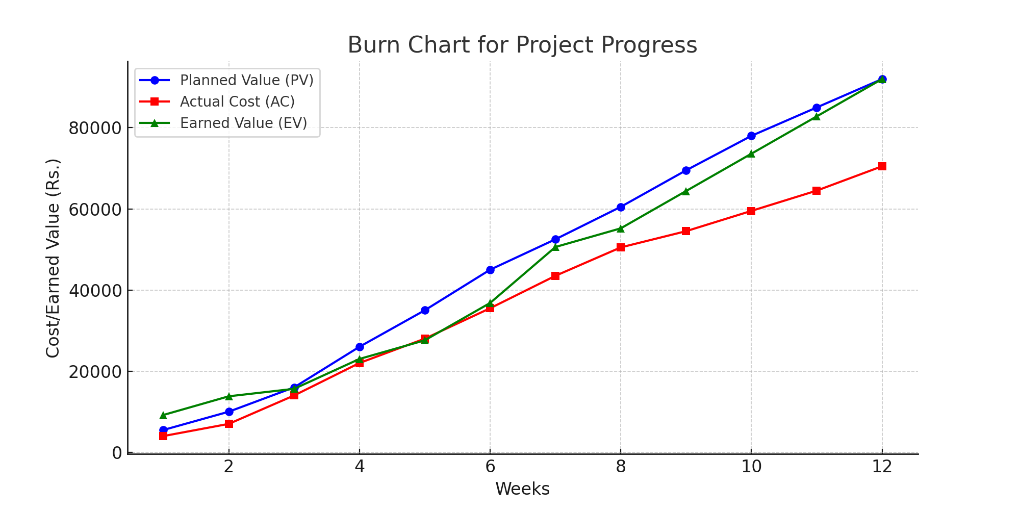

* **Proposed Enhancement**

**6.1. Proposed Enhancement**

**1. Improved Crop Listing and Management:**

* Develop a structured and organized system where farmers can list available crops, farming methods, and expected yield.
* Ensure clear communication between farmers, buyers, and agricultural experts.

**2. Better Coordination Between Farmers and Marketplaces:**

* Assign a dedicated agricultural coordinator to facilitate smooth communication between farmers and buyers.
* Maintain a well-structured harvest and supply calendar to prevent market saturation and price fluctuations.

**3. User-Friendly Online Portal:**

* Develop an easy-to-use portal where farmers can register, update crop details, and connect with buyers.
* Ensure traders and agricultural businesses can access farmer profiles and purchase produce efficiently.

**4. Effective Training and Guidance for Farmers:**

* Conduct workshops and provide guides on modern farming techniques, pest control, and sustainable agriculture.
* Offer assistance on financial planning, loan applications, and government grant access.

**5. Stronger Industry Connections:**

* Invite agricultural experts, scientists, and successful farmers for guest lectures and advisory sessions.
* Arrange networking events where farmers can interact with suppliers, distributors, and agricultural investors.

**6. Feedback System for Continuous Improvement:**

* Collect feedback from farmers, buyers, and agricultural experts about the system's effectiveness.
* Make necessary improvements based on feedback to enhance efficiency and productivity.

**7. Post-Harvest Support and Market Guidance:**

* Guide farmers on storage, transportation, and market expectations for selling their produce.
* Maintain a database of successful agricultural practices to track progress and improve future strategies.
* **Conclusion**

**7.1. Conclusion**

The Agriculture Management System plays a crucial role in modernizing and optimizing agricultural practices. By leveraging technology, it enhances efficiency, productivity, and sustainability in farming. The system facilitates better decision-making through data-driven insights, streamlines resource allocation, and improves communication between farmers, suppliers, and consumers.

With features like crop monitoring, weather forecasting, inventory management, and automated reporting, the system helps farmers maximize yields while minimizing costs and environmental impact.

In conclusion, adopting an Agriculture Management System is a significant step toward a more efficient and sustainable agricultural sector. It empowers farmers with modern tools to increase profitability while promoting responsible resource use, ultimately contributing to global food security and economic growth.

* **Bibliography**

**8.1. Bibliography**

* The Bibliography contains references to all the documents that were used to develop the software.
* Web Site:
  + [www.geeksforgeeks.com](http://www.geeksforgeeks.com)
  + [https://www.javatpoint.com](https://www.javatpoint.com/)
  + [https://www.w3schools.com](https://www.w3schools.com/)
  + <https://stackoverflow.com>